**ANNEXTURES: DISTRICT FIGURES AND TABLES**

**Annex 1: BANKURA DISTRICT**

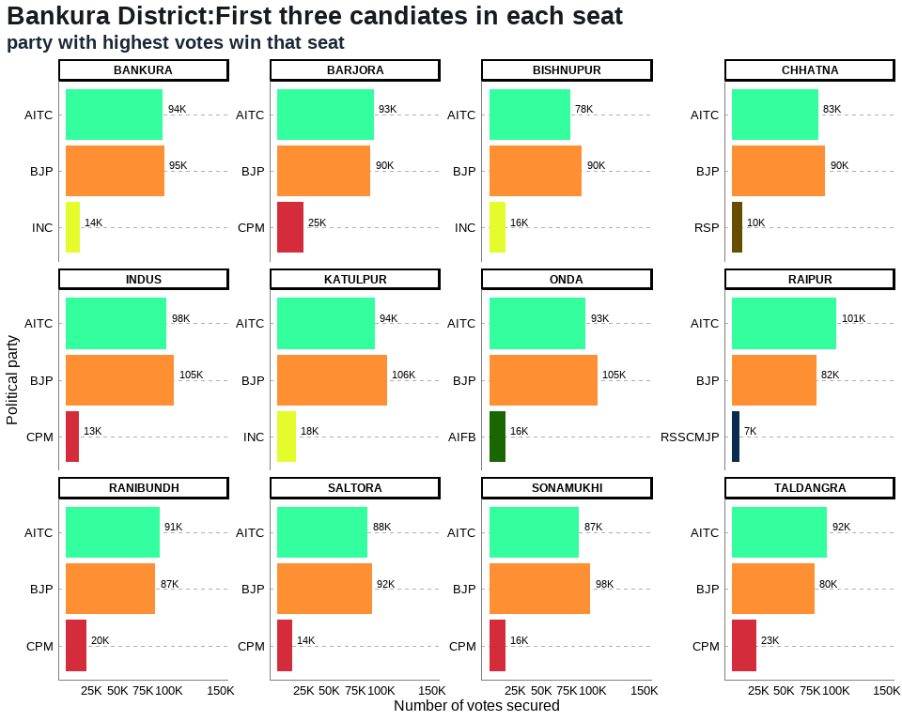

## Figure 14: BANKURA District: Winners per constituency and top 3 candidates

## Table 3: BANKURA District Election Results: Top 3 Candidates by Votes in Each Constituency

| **Constituency** | **Type** | **Party** | **Candidate** | **Position** | **Votes** | **Margin** |
| --- | --- | --- | --- | --- | --- | --- |
| BANKURA | GEN | BJP | Niladri Sekhar Dana | 1 | 95,466 | 1,468 |
| BANKURA | GEN | AITC | Sayantika Banerjee | 2 | 93,998 | 80,234 |
| BANKURA | GEN | INC | Radharani Banerjee | 3 | 13,764 | 9,257 |
| BARJORA | GEN | AITC | Alok Mukherjee | 1 | 93,290 | 3,269 |
| BARJORA | GEN | BJP | Supriti Chatterjee | 2 | 90,021 | 64,786 |
| BARJORA | GEN | CPM | Sujit Chakraborty | 3 | 25,235 | 20,332 |
| BISHNUPUR | GEN | BJP | Tanmay Ghosh (Bumba) | 1 | 89,689 | 11,420 |
| BISHNUPUR | GEN | AITC | Archita Bid | 2 | 78,269 | 62,455 |
| BISHNUPUR | GEN | INC | Debu Chatterjee | 3 | 15,814 | 12,395 |
| CHHATNA | GEN | BJP | Satyanarayan Mukhopadhyay | 1 | 90,233 | 7,164 |
| CHHATNA | GEN | AITC | Subasish Batabyal | 2 | 83,069 | 73,369 |
| CHHATNA | GEN | RSP | Falguni Mukherjee | 3 | 9,700 | 6,186 |
| INDUS | SC | BJP | Nirmal Kumar Dhara | 1 | 104,936 | 7,220 |
| INDUS | SC | AITC | Runu Mete | 2 | 97,716 | 85,097 |
| INDUS | SC | CPM | Nayan Kumar Shill (Bagdi) | 3 | 12,619 | 9,437 |
| KATULPUR | SC | BJP | Harakali Protiher | 1 | 106,022 | 11,785 |
| KATULPUR | SC | AITC | Sangeeta Malik | 2 | 94,237 | 76,480 |
| KATULPUR | SC | INC | Akshay Santra | 3 | 17,757 | 15,238 |
| ONDA | GEN | BJP | Amarnath Shakha | 1 | 104,940 | 11,551 |
| ONDA | GEN | AITC | Arup Kumar Khan | 2 | 93,389 | 77,776 |
| ONDA | GEN | AIFB | Tarapada Chakrabarti | 3 | 15,613 | 10,734 |
| RAIPUR | ST | AITC | Mrityunjoy Murmu | 1 | 101,043 | 19,398 |
| RAIPUR | ST | BJP | Sudhanshu Hansda | 2 | 81,645 | 75,052 |
| RAIPUR | ST | RSSCMJP | Milan Mandi | 3 | 6,593 | 3,607 |
| RANIBUNDH | ST | AITC | Jyotsna Mandi | 1 | 90,928 | 3,939 |
| RANIBUNDH | ST | BJP | Kshudiram Tudu | 2 | 86,989 | 66,932 |
| RANIBUNDH | ST | CPM | Deblina Hembram | 3 | 20,057 | 15,250 |
| SALTORA | SC | BJP | Bauri Chandana | 1 | 91,648 | 4,145 |
| SALTORA | SC | AITC | Sontosh Kumar Mondal | 2 | 87,503 | 73,419 |
| SALTORA | SC | CPM | Nandadulal Bauri | 3 | 14,084 | 10,530 |
| SONAMUKHI | SC | BJP | Dibakar Gharami | 1 | 98,161 | 10,888 |
| SONAMUKHI | SC | AITC | Dr. Shyamal Santra | 2 | 87,273 | 71,548 |
| SONAMUKHI | SC | CPM | Ajit Ray | 3 | 15,725 | 12,953 |
| TALDANGRA | GEN | AITC | Arup Chakraborty | 1 | 92,026 | 12,377 |
| TALDANGRA | GEN | BJP | Shyamal Kumar Sarkar (Benu) | 2 | 79,649 | 56,460 |
| TALDANGRA | GEN | CPM | Manoranjan Patra | 3 | 23,189 | 19,671 |

## Annex 2: BARDHAMAN DISTRICT

## 2. BARDHAMAN District: Winners per constituency and top 3 candidates

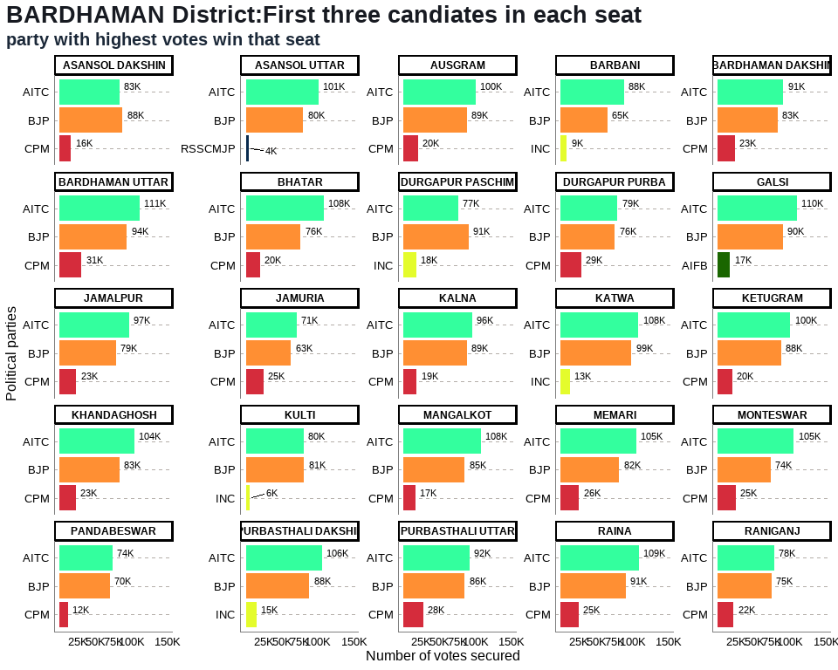

## Table 3: BARDHAMAN District Election Results: Top 3 Candidates by Votes in Each Constituency

| **Constituency** | **Type** | **Party** | **Candidate** | **Position** | **Votes** | **Margin** |
| --- | --- | --- | --- | --- | --- | --- |
| ASANSOL DAKSHIN | GEN | BJP | Agnimitra Paul | 1 | 87,881 | 4,487 |
| ASANSOL DAKSHIN | GEN | AITC | Sayani Ghosh | 2 | 83,394 | 67,422 |
| ASANSOL DAKSHIN | GEN | CPM | Prasanta Ghosh | 3 | 15,972 | 12,506 |
| ASANSOL UTTAR | GEN | AITC | Ghatak Moloy | 1 | 100,931 | 21,110 |
| ASANSOL UTTAR | GEN | BJP | Krishnendu Mukherjee | 2 | 79,821 | 75,350 |
| ASANSOL UTTAR | GEN | RSSCMJP | Mohammad Mustaqim | 3 | 4,471 | 1,123 |
| AUSGRAM | SC | AITC | Abhedananda Thander | 1 | 100,392 | 11,815 |
| AUSGRAM | SC | BJP | Kalita Maji | 2 | 88,577 | 68,178 |
| AUSGRAM | SC | CPM | Chanchal Kumar Majhi | 3 | 20,399 | 16,360 |
| BARBANI | GEN | AITC | Bidhan Upadhyay | 1 | 88,430 | 23,457 |
| BARBANI | GEN | BJP | Arijit Roy | 2 | 64,973 | 56,011 |
| BARBANI | GEN | INC | Ranendra Nath Bagchi | 3 | 8,962 | 5,923 |
| BARDHAMAN DAKSHIN | GEN | AITC | Khokan Das | 1 | 91,015 | 8,105 |
| BARDHAMAN DAKSHIN | GEN | BJP | Sandip Nandi | 2 | 82,910 | 59,564 |
| BARDHAMAN DAKSHIN | GEN | CPM | Pritha Tah | 3 | 23,346 | 19,639 |
| BARDHAMAN UTTAR | SC | AITC | Nisith Kumar Malik | 1 | 111,211 | 17,268 |
| BARDHAMAN UTTAR | SC | BJP | Radha Kanta Roy | 2 | 93,943 | 62,915 |
| BARDHAMAN UTTAR | SC | CPM | Chandi Choran Let | 3 | 31,028 | 27,681 |
| BHATAR | GEN | AITC | Adhikari Mangobinda | 1 | 108,028 | 31,741 |
| BHATAR | GEN | BJP | Mahendranath Kowar | 2 | 76,287 | 56,680 |
| BHATAR | GEN | CPM | Nazrul Haque | 3 | 19,607 | 15,261 |
| DURGAPUR PASCHIM | GEN | BJP | Lakshman Chandra Ghorui | 1 | 91,186 | 14,664 |
| DURGAPUR PASCHIM | GEN | AITC | Biswanath Parial | 2 | 76,522 | 58,492 |
| DURGAPUR PASCHIM | GEN | INC | Debesh Chakraborty | 3 | 18,030 | 15,406 |
| DURGAPUR PURBA | GEN | AITC | Pradip Mazumdar | 1 | 79,303 | 3,746 |
| DURGAPUR PURBA | GEN | BJP | Colonel Diptansu Chaudhury | 2 | 75,557 | 46,494 |
| DURGAPUR PURBA | GEN | CPM | Abhas Ray Chaudhuri | 3 | 29,063 | 26,435 |
| GALSI | SC | AITC | Nepal Ghorui | 1 | 109,504 | 19,262 |
| GALSI | SC | BJP | Bikash Biswas | 2 | 90,242 | 73,222 |
| GALSI | SC | AIFB | Nandalal Pondit | 3 | 17,020 | 13,502 |
| JAMALPUR | SC | AITC | Alok Kumar Majhi | 1 | 96,999 | 17,971 |
| JAMALPUR | SC | BJP | Balaram Bapari | 2 | 79,028 | 55,730 |
| JAMALPUR | SC | CPM | Samar Hazra | 3 | 23,298 | 20,433 |
| JAMURIA | GEN | AITC | Hareram Singh | 1 | 71,002 | 8,051 |
| JAMURIA | GEN | BJP | Tapas Kumar Roy | 2 | 62,951 | 38,133 |
| JAMURIA | GEN | CPM | Aishe Ghosh | 3 | 24,818 | 22,409 |
| KALNA | SC | AITC | Deboprasad Bag (Poltu) | 1 | 96,073 | 7,478 |
| KALNA | SC | BJP | Biswajit Kundu | 2 | 88,595 | 69,590 |
| KALNA | SC | CPM | Nirab Khan | 3 | 19,005 | 16,498 |
| KATWA | GEN | AITC | Rabindranath Chatterjee | 1 | 107,894 | 9,155 |
| KATWA | GEN | BJP | Shyama Majumdar | 2 | 98,739 | 85,763 |
| KATWA | GEN | INC | Prabir Ganguli | 3 | 12,976 | 11,196 |
| KETUGRAM | GEN | AITC | Sekh Sahonawez | 1 | 100,226 | 12,683 |
| KETUGRAM | GEN | BJP | Anadi Ghosh (Mathura) | 2 | 87,543 | 67,451 |
| KETUGRAM | GEN | CPM | Mizanul Kabir (Dhiraj) | 3 | 20,092 | 16,472 |
| KHANDAGHOSH | SC | AITC | Nabin Chandra Bag | 1 | 104,264 | 20,886 |
| KHANDAGHOSH | SC | BJP | Bijan Mandal | 2 | 83,378 | 60,455 |
| KHANDAGHOSH | SC | CPM | Asima Roy | 3 | 22,923 | 19,458 |
| KULTI | GEN | BJP | Ajay Kumar Poddar | 1 | 81,112 | 679 |
| KULTI | GEN | AITC | Ujjal Chatterjee | 2 | 80,433 | 74,638 |
| KULTI | GEN | INC | Chandi Das Chatterjee | 3 | 5,795 | 2,242 |
| MANGALKOT | GEN | AITC | Apurba Chowdhury (Achal) | 1 | 107,596 | 22,337 |
| MANGALKOT | GEN | BJP | Rana Protap Goswami | 2 | 85,259 | 68,476 |
| MANGALKOT | GEN | CPM | Choudhury Sahajahan | 3 | 16,783 | 12,957 |
| MEMARI | GEN | AITC | Madhusudan Bhattacharya | 1 | 104,851 | 23,078 |
| MEMARI | GEN | BJP | Bhismadeb Bhattacharya | 2 | 81,773 | 56,155 |
| MEMARI | GEN | CPM | Sanat Banerjee | 3 | 25,618 | 23,497 |
| MONTESWAR | GEN | AITC | Chowdhury Siddiqullah | 1 | 105,460 | 31,805 |
| MONTESWAR | GEN | BJP | Saikat Panja | 2 | 73,655 | 48,915 |
| MONTESWAR | GEN | CPM | Anupam Ghosh | 3 | 24,740 | 22,863 |
| PANDABESWAR | GEN | AITC | Narendranath Chakraborty | 1 | 73,922 | 3,803 |
| PANDABESWAR | GEN | BJP | Kumar Jitendra Tewari | 2 | 70,119 | 57,923 |
| PANDABESWAR | GEN | CPM | Subhas Bauri | 3 | 12,196 | 9,461 |
| PURBASTHALI DAKSHIN | GEN | AITC | Swapan Debnath | 1 | 105,698 | 17,410 |
| PURBASTHALI DAKSHIN | GEN | BJP | Rajib Kumar Bhowmick | 2 | 88,288 | 73,227 |
| PURBASTHALI DAKSHIN | GEN | INC | Abhijit Bhattacharyya | 3 | 15,061 | 11,956 |
| PURBASTHALI UTTAR | GEN | AITC | Tapan Chatterjee | 1 | 92,421 | 6,706 |
| PURBASTHALI UTTAR | GEN | BJP | Gobardhan Das | 2 | 85,715 | 57,581 |
| PURBASTHALI UTTAR | GEN | CPM | Pradip Kumar Saha | 3 | 28,134 | 26,227 |
| RAINA | SC | AITC | Shampa Dhara | 1 | 108,752 | 18,205 |
| RAINA | SC | BJP | Manik Roy | 2 | 90,547 | 65,215 |
| RAINA | SC | CPM | Basudeb Khan | 3 | 25,332 | 23,461 |
| RANIGANJ | GEN | AITC | Tapas Banerjee | 1 | 78,164 | 3,556 |
| RANIGANJ | GEN | BJP | Dr. Bijan Mukherjee | 2 | 74,608 | 52,920 |
| RANIGANJ | GEN | CPM | Hemant Kumar Prabhakar | 3 | 21,688 | 19,682 |

## Annex 3: BIRBHUM DISTRICT

## 3. BIRBHUM District: Winners per constituency and top 3 candidates

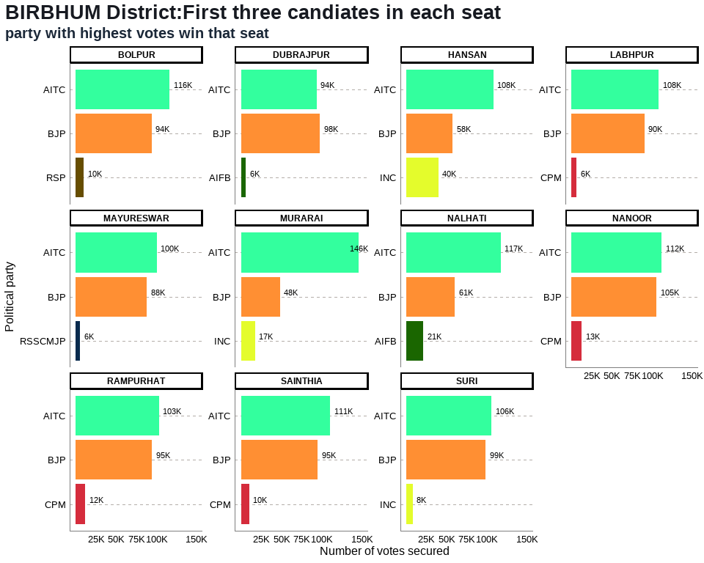

## Table 4: BIRBHUM District Election Results: Top 3 Candidates by Votes in Each Constituency

| **Constituency** | **Type** | **Party** | **Candidate** | **Position** | **Votes** | **Margin** |
| --- | --- | --- | --- | --- | --- | --- |
| BOLPUR | GEN | AITC | Sinha Chandranath | 1 | 116,443 | 22,280 |
| BOLPUR | GEN | BJP | Anirban Ganguly | 2 | 94,163 | 84,198 |
| BOLPUR | GEN | RSP | Tapan Hore | 3 | 9,965 | 6,628 |
| DUBRAJPUR | SC | BJP | Anup Kumar Saha | 1 | 98,083 | 3,863 |
| DUBRAJPUR | SC | AITC | Debabrata Saha | 2 | 94,220 | 88,206 |
| DUBRAJPUR | SC | AIFB | Bijoy Bagdi | 3 | 6,014 | 2,857 |
| HANSAN | GEN | AITC | Dr. Asok Kumar Chattopadhyay | 1 | 108,289 | 50,613 |
| HANSAN | GEN | BJP | Nikhil Banerjee | 2 | 57,676 | 17,861 |
| HANSAN | GEN | INC | Miltan Rasid | 3 | 39,815 | 37,395 |
| LABHPUR | GEN | AITC | Abhijit Sinha (Rana) | 1 | 108,423 | 17,975 |
| LABHPUR | GEN | BJP | Biswajit Mondal | 2 | 90,448 | 83,969 |
| LABHPUR | GEN | CPM | Syed Mahfuzul Karim | 3 | 6,479 | 3,422 |
| MAYURESWAR | GEN | AITC | Abhijit Roy | 1 | 100,425 | 12,075 |
| MAYURESWAR | GEN | BJP | Shyamapada Mondal | 2 | 88,350 | 82,788 |
| MAYURESWAR | GEN | RSSCMJP | Kashinath Pal | 3 | 5,562 | 2,759 |
| MURARAI | GEN | AITC | Dr Mosarraf Hossain | 1 | 146,496 | 98,246 |
| MURARAI | GEN | BJP | Debasish Roy | 2 | 48,250 | 30,963 |
| MURARAI | GEN | INC | Asif Ekbal | 3 | 17,287 | 15,430 |
| NALHATI | GEN | AITC | Rajendra Prasad Singh (Raju Singh) | 1 | 117,438 | 56,905 |
| NALHATI | GEN | BJP | Tapas Kumar Yadav(Ananda Yadav) | 2 | 60,533 | 39,205 |
| NALHATI | GEN | AIFB | Dipak Chatterjee | 3 | 21,328 | 19,428 |
| NANOOR | SC | AITC | Bidhan Chandra Majhi | 1 | 112,116 | 6,670 |
| NANOOR | SC | BJP | Tarakeswar Saha | 2 | 105,446 | 92,568 |
| NANOOR | SC | CPM | Shyamali Pradhan | 3 | 12,878 | 10,139 |
| RAMPURHAT | GEN | AITC | Asish Banerjee | 1 | 103,276 | 8,472 |
| RAMPURHAT | GEN | BJP | Subhasis Choudhury (Khokan) | 2 | 94,804 | 83,097 |
| RAMPURHAT | GEN | CPM | Sanjib Barman (Gopi) | 3 | 11,707 | 8,326 |
| SAINTHIA | SC | AITC | Nilabati Saha | 1 | 110,572 | 15,243 |
| SAINTHIA | SC | BJP | Piya Saha | 2 | 95,329 | 84,960 |
| SAINTHIA | SC | CPM | Mausumi Konai | 3 | 10,369 | 8,271 |
| SURI | GEN | AITC | Bikash Roychoudhury | 1 | 105,871 | 7,320 |
| SURI | GEN | BJP | Chattopadhyay Jagannath | 2 | 98,551 | 90,284 |
| SURI | GEN | INC | Chanchal Chatterjee | 3 | 8,267 | 6,183 |

## Annex 4: COOCH BEHAR DISTRICT

## 4. COOCH BEHAR District: Winners per constituency and top 3 candidates

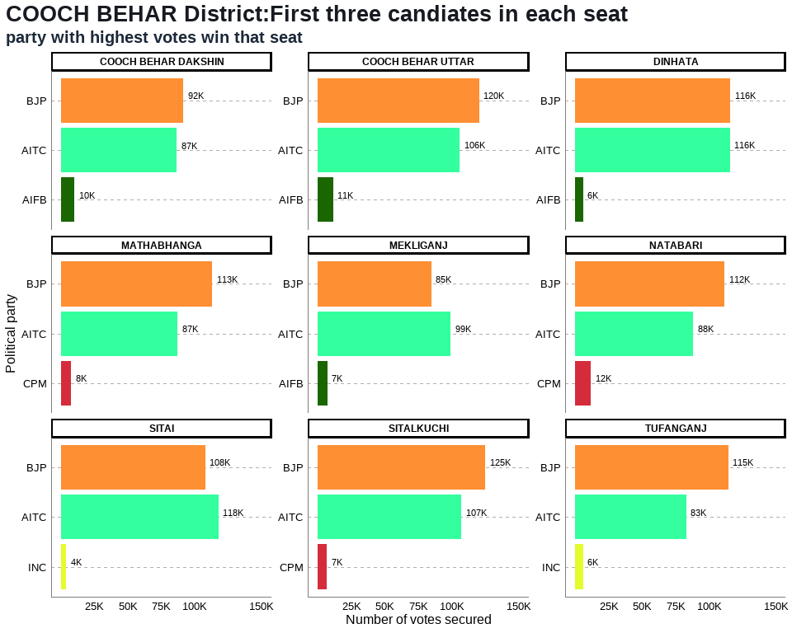

## Table 5: COOCH BEHAR District Election Results: Top 3 Candidates by Votes in Each Constituency

| **Constituency** | **Type** | **Party** | **Candidate** | **Position** | **Votes** | **Margin** |
| --- | --- | --- | --- | --- | --- | --- |
| COOCH BEHAR DAKSHIN | GEN | BJP | Nikhil Ranjan Dey | 1 | 91,560 | 4,931 |
| COOCH BEHAR DAKSHIN | GEN | AITC | Avijit De Bhowmik | 2 | 86,629 | 76,383 |
| COOCH BEHAR DAKSHIN | GEN | AIFB | Akshay Thakur | 3 | 10,246 | 8,761 |
| COOCH BEHAR UTTAR | SC | BJP | Sukumar Roy | 1 | 120,483 | 14,615 |
| COOCH BEHAR UTTAR | SC | AITC | Binay Krishna Barman | 2 | 105,868 | 94,393 |
| COOCH BEHAR UTTAR | SC | AIFB | Nagendra Nath Roy | 3 | 11,475 | 9,905 |
| DINHATA | GEN | BJP | Nisith Pramanik | 1 | 116,035 | 57 |
| DINHATA | GEN | AITC | Udayan Guha | 2 | 115,978 | 109,909 |
| DINHATA | GEN | AIFB | Abdur Rouf | 3 | 6,069 | 4,532 |
| MATHABHANGA | SC | BJP | Sushil Barman | 1 | 113,249 | 26,134 |
| MATHABHANGA | SC | AITC | Girindra Nath Barman | 2 | 87,115 | 79,397 |
| MATHABHANGA | SC | CPM | Ashok Barman | 3 | 7,718 | 6,275 |
| MEKLIGANJ | SC | AITC | Adhikary Paresh Chandra | 1 | 99,338 | 14,685 |
| MEKLIGANJ | SC | BJP | Dadhiram Ray | 2 | 84,653 | 77,800 |
| MEKLIGANJ | SC | AIFB | Gobinda Chandra Roy | 3 | 6,853 | 4,406 |
| NATABARI | GEN | BJP | Mihir Goswami | 1 | 111,743 | 23,440 |
| NATABARI | GEN | AITC | Rabindra Nath Ghosh | 2 | 88,303 | 76,464 |
| NATABARI | GEN | CPM | Akik Hassan | 3 | 11,839 | 10,498 |
| SITAI | SC | AITC | Jagadish Chandra Barma Basunia | 1 | 117,908 | 10,112 |
| SITAI | SC | BJP | Dipak Kumar Roy | 2 | 107,796 | 103,832 |
| SITAI | SC | INC | Keshab Chandra Ray | 3 | 3,964 | 1,573 |
| SITALKUCHI | SC | BJP | Baren Chandra Barman | 1 | 124,955 | 17,815 |
| SITALKUCHI | SC | AITC | Partha Pratim Ray | 2 | 107,140 | 100,420 |
| SITALKUCHI | SC | CPM | Sudhangshu Pramanik | 3 | 6,720 | 3,977 |
| TUFANGANJ | GEN | BJP | Malati Rava Roy | 1 | 114,503 | 31,198 |
| TUFANGANJ | GEN | AITC | Pranab Kumar Dey | 2 | 83,305 | 77,332 |
| TUFANGANJ | GEN | INC | Rabin Roy | 3 | 5,973 | 3,904 |

## Annex 5: DAKSHIN DINAJPUR DISTRICT

## 5. DAKSHIN DINAJPUR District: Winners per constituency and top 3 candidates

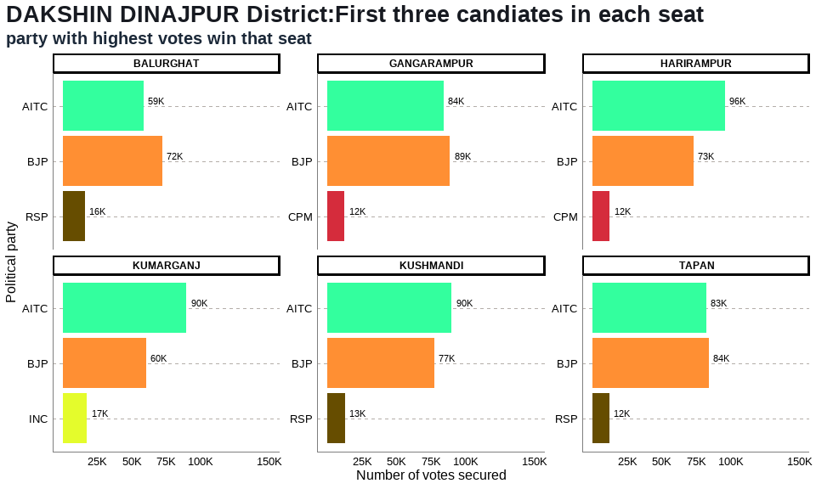

## Table 6: DAKSHIN DINAJPUR District Election Results: Top 3 Candidates by Votes in Each Constituency

| **Constituency** | **Type** | **Party** | **Candidate** | **Position** | **Votes** | **Margin** |
| --- | --- | --- | --- | --- | --- | --- |
| BALURGHAT | GEN | BJP | Ashok Kumar Lahiri | 1 | 72,129 | 13,436 |
| BALURGHAT | GEN | AITC | Sekhar Dasgupta | 2 | 58,693 | 42,540 |
| BALURGHAT | GEN | RSP | Sucheta Biswas | 3 | 16,153 | 14,323 |
| GANGARAMPUR | SC | BJP | Satyendra Nath Ray | 1 | 88,724 | 4,592 |
| GANGARAMPUR | SC | AITC | Goutam Das | 2 | 84,132 | 71,859 |
| GANGARAMPUR | SC | CPM | Nanda Lal Hazra | 3 | 12,273 | 11,104 |
| HARIRAMPUR | GEN | AITC | Biplab Mitra | 1 | 96,131 | 22,672 |
| HARIRAMPUR | GEN | BJP | Nilanjan Roy | 2 | 73,459 | 61,015 |
| HARIRAMPUR | GEN | CPM | Rafikul Islam | 3 | 12,444 | 10,613 |
| KUMARGANJ | GEN | AITC | Toraf Hossain Mandal | 1 | 89,763 | 29,367 |
| KUMARGANJ | GEN | BJP | Manas Sarkar | 2 | 60,396 | 42,918 |
| KUMARGANJ | GEN | INC | Chaudhuri Nargis Banu | 3 | 17,478 | 16,263 |
| KUSHMANDI | SC | AITC | Rekha Roy | 1 | 89,968 | 12,584 |
| KUSHMANDI | SC | BJP | Ranjit Kumar Roy | 2 | 77,384 | 64,813 |
| KUSHMANDI | SC | RSP | Narmada Chandra Roy | 3 | 12,571 | 10,973 |
| TAPAN | ST | BJP | Budhrai Tudu | 1 | 84,381 | 1,650 |
| TAPAN | ST | AITC | Kalpana Kisku | 2 | 82,731 | 70,643 |
| TAPAN | ST | RSP | Raghu Urow | 3 | 12,088 | 9,942 |

## Annex 6: DARJEELING DISTRICT

## 6. DARJEELING District: Winners per constituency and top 3 candidates

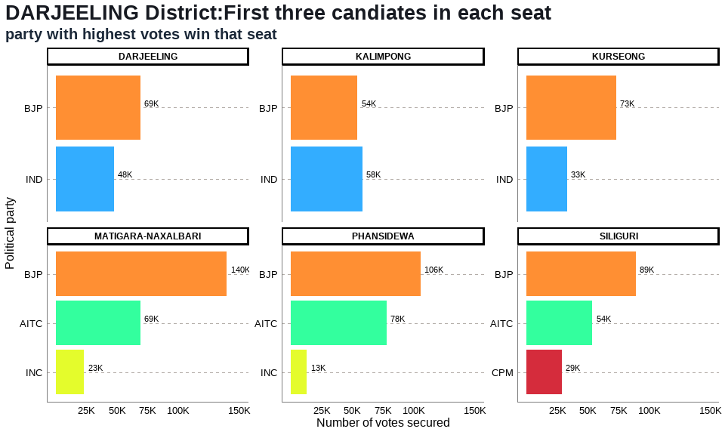

## Table 7: DARJEELING District Election Results: Top 3 Candidates by Votes in Each Constituency

| **Constituency** | **Type** | **Party** | **Candidate** | **Position** | **Votes** | **Margin** |
| --- | --- | --- | --- | --- | --- | --- |
| DARJEELING | GEN | BJP | Neeraj Tamang Zimba | 1 | 68,907 | 21,276 |
| DARJEELING | GEN | IND | Keshav Raj Sharma | 2 | 47,631 | 9,391 |
| DARJEELING | GEN | IND | Pemba Tshering | 3 | 38,240 | 35,385 |
| KALIMPONG | GEN | IND | Ruden Sada Lepcha | 1 | 58,206 | 3,870 |
| KALIMPONG | GEN | BJP | Suva Pradhan | 2 | 54,336 | 22,480 |
| KALIMPONG | GEN | IND | Dr. R.b. Bhujel | 3 | 31,856 | 29,696 |
| KURSEONG | GEN | BJP | Bishnu Prasad Sharma (Alias B.p. Bajgain) | 1 | 73,475 | 15,515 |
| KURSEONG | GEN | IND | Tshering Lama | 2 | 57,960 | 24,866 |
| KURSEONG | GEN | IND | Narbu Lama | 3 | 33,094 | 30,549 |
| MATIGARA-NAXALBARI | SC | BJP | Anandamay Barman | 1 | 139,785 | 70,848 |
| MATIGARA-NAXALBARI | SC | AITC | Rajen Sundas | 2 | 68,937 | 45,877 |
| MATIGARA-NAXALBARI | SC | INC | Sankar Malakar | 3 | 23,060 | 19,148 |
| PHANSIDEWA | ST | BJP | Durga Murmu | 1 | 105,651 | 27,711 |
| PHANSIDEWA | ST | AITC | Chhotan Kisku | 2 | 77,940 | 65,125 |
| PHANSIDEWA | ST | INC | Sunil Chandra Tirkey | 3 | 12,815 | 10,028 |
| SILIGURI | GEN | BJP | Sankar Ghosh | 1 | 89,370 | 35,586 |
| SILIGURI | GEN | AITC | Dr. Omprakash Mishra | 2 | 53,784 | 24,949 |
| SILIGURI | GEN | CPM | Asok Bhattacharya | 3 | 28,835 | 26,761 |

## Annex 7: HOOGHLY DISTRICT

## 7. HOOGHLY District: Winners per constituency and top 3 candidates

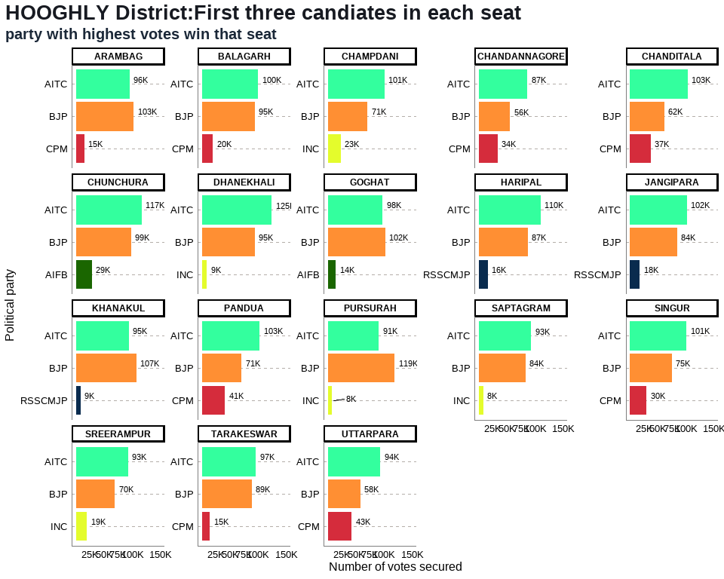

## Table 8: HOOGHLY District Election Results: Top 3 Candidates by Votes in Each Constituency

| **Constituency** | **Type** | **Party** | **Candidate** | **Position** | **Votes** | **Margin** |
| --- | --- | --- | --- | --- | --- | --- |
| ARAMBAG | SC | BJP | Madhusudan Bag | 1 | 103,108 | 7,172 |
| ARAMBAG | SC | AITC | Sujata Mondal | 2 | 95,936 | 80,971 |
| ARAMBAG | SC | CPM | Sakti Mohon Malik | 3 | 14,965 | 11,794 |
| BALAGARH | SC | AITC | Manoranjan Bapari | 1 | 100,364 | 5,784 |
| BALAGARH | SC | BJP | Subhas Chandra Haldar | 2 | 94,580 | 74,814 |
| BALAGARH | SC | CPM | Mahamaya Mondal | 3 | 19,766 | 16,661 |
| CHAMPDANI | GEN | AITC | Arindam Guin (Bubai) | 1 | 100,972 | 30,078 |
| CHAMPDANI | GEN | BJP | Dilip Singh | 2 | 70,894 | 47,622 |
| CHAMPDANI | GEN | INC | Abdul Mannan | 3 | 23,272 | 19,925 |
| CHANDANNAGORE | GEN | AITC | Indranil Sen | 1 | 86,778 | 31,029 |
| CHANDANNAGORE | GEN | BJP | Deepanjan Kumar Guha | 2 | 55,749 | 22,047 |
| CHANDANNAGORE | GEN | CPM | Gautam Sarkar | 3 | 33,702 | 30,679 |
| CHANDITALA | GEN | AITC | Swati Khandoker | 1 | 103,118 | 41,347 |
| CHANDITALA | GEN | BJP | Debashish Dasgupta(Yash D Guptaa) | 2 | 61,771 | 24,610 |
| CHANDITALA | GEN | CPM | Md. Salim | 3 | 37,161 | 35,005 |
| CHUNCHURA | GEN | AITC | Asit Mazumder (Tapan) | 1 | 117,104 | 18,417 |
| CHUNCHURA | GEN | BJP | Locket Chatterjee | 2 | 98,687 | 69,910 |
| CHUNCHURA | GEN | AIFB | Pranab Kumar Ghosh | 3 | 28,777 | 24,439 |
| DHANEKHALI | SC | AITC | Asima Patra | 1 | 124,776 | 30,159 |
| DHANEKHALI | SC | BJP | Tusar Kumar Majumdar | 2 | 94,617 | 85,584 |
| DHANEKHALI | SC | INC | Anirban Saha | 3 | 9,033 | 5,803 |
| GOGHAT | SC | BJP | Biswanath Karak | 1 | 102,227 | 4,147 |
| GOGHAT | SC | AITC | Manas Majumdar | 2 | 98,080 | 83,702 |
| GOGHAT | SC | AIFB | Shiba Prasad Malick | 3 | 14,378 | 11,896 |
| HARIPAL | GEN | AITC | Dr. Karabi Manna | 1 | 110,215 | 23,072 |
| HARIPAL | GEN | BJP | Samiran Mitra | 2 | 87,143 | 71,348 |
| HARIPAL | GEN | RSSCMJP | Simal Saren | 3 | 15,795 | 12,428 |
| JANGIPARA | GEN | AITC | Snehasis Chakraborty | 1 | 101,885 | 17,926 |
| JANGIPARA | GEN | BJP | Debjit Sarkar | 2 | 83,959 | 66,203 |
| JANGIPARA | GEN | RSSCMJP | Sk. Mainuddin | 3 | 17,756 | 14,716 |
| KHANAKUL | GEN | BJP | Susanta Ghosh | 1 | 107,403 | 12,884 |
| KHANAKUL | GEN | AITC | Munsi Nazbul Karim | 2 | 94,519 | 85,787 |
| KHANAKUL | GEN | RSSCMJP | Faisal Khan | 3 | 8,732 | 5,454 |
| PANDUA | GEN | AITC | Dr. Ratna De Nag | 1 | 102,874 | 31,858 |
| PANDUA | GEN | BJP | Partha Sharma | 2 | 71,016 | 29,542 |
| PANDUA | GEN | CPM | Amjad Hossain Sk. | 3 | 41,474 | 39,310 |
| PURSURAH | GEN | BJP | Biman Ghosh | 1 | 119,334 | 28,178 |
| PURSURAH | GEN | AITC | Dilip Yadav | 2 | 91,156 | 83,328 |
| PURSURAH | GEN | INC | Monika Malik Ghosh | 3 | 7,828 | 5,040 |
| SAPTAGRAM | GEN | AITC | Tapan Dasgupta | 1 | 93,328 | 9,772 |
| SAPTAGRAM | GEN | BJP | Debabrata Biswas | 2 | 83,556 | 75,224 |
| SAPTAGRAM | GEN | INC | Pabitra Deb | 3 | 8,332 | 5,295 |
| SINGUR | GEN | AITC | Becharam Manna | 1 | 101,077 | 25,923 |
| SINGUR | GEN | BJP | Rabindranath Bhattacharya | 2 | 75,154 | 45,138 |
| SINGUR | GEN | CPM | Srijan Bhattacharyya | 3 | 30,016 | 27,671 |
| SREERAMPUR | GEN | AITC | Dr. Sudipto Roy | 1 | 93,021 | 23,433 |
| SREERAMPUR | GEN | BJP | Kabir Shankar Bose | 2 | 69,588 | 50,187 |
| SREERAMPUR | GEN | INC | Alok Ranjan Banerjee | 3 | 19,401 | 17,001 |
| TARAKESWAR | GEN | AITC | Ramendu Sinharay | 1 | 96,698 | 7,484 |
| TARAKESWAR | GEN | BJP | Dr. Swapan Dasgupta | 2 | 89,214 | 74,619 |
| TARAKESWAR | GEN | CPM | Surajit Ghosh | 3 | 14,595 | 11,843 |
| UTTARPARA | GEN | AITC | Kanchan Mullick | 1 | 93,878 | 35,989 |
| UTTARPARA | GEN | BJP | Prabir Kumar Ghosal | 2 | 57,889 | 15,171 |
| UTTARPARA | GEN | CPM | Rajat Banerjee (Bappa) | 3 | 42,718 | 39,365 |

## Annex 8: HOWRAH DISTRICT

## 8. HOWRAH District: Winners per constituency and top 3 candidates

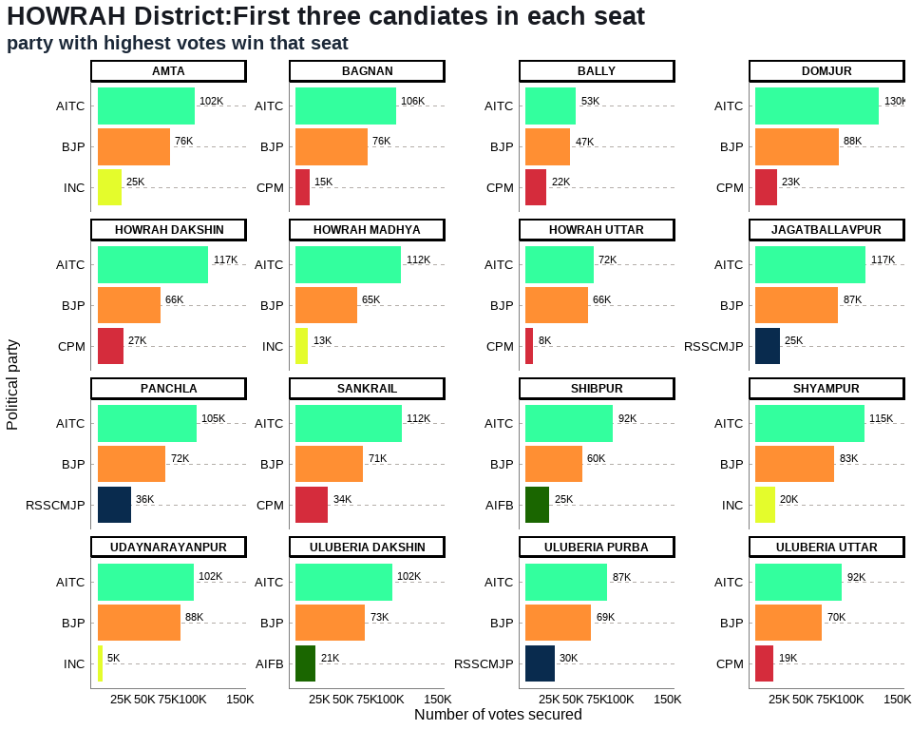

## Table 9: HOWRAH District Election Results: Top 3 Candidates by Votes in Each Constituency

| **Constituency** | **Type** | **Party** | **Candidate** | **Position** | **Votes** | **Margin** |
| --- | --- | --- | --- | --- | --- | --- |
| AMTA | GEN | AITC | Sukanta Kumar Paul | 1 | 102,445 | 26,205 |
| AMTA | GEN | BJP | Debtanu Bhattacharya | 2 | 76,240 | 51,131 |
| AMTA | GEN | INC | Asit Mitra | 3 | 25,109 | 23,807 |
| BAGNAN | GEN | AITC | Arunava Sen (Raja) | 1 | 106,042 | 30,120 |
| BAGNAN | GEN | BJP | Anupam Mallik | 2 | 75,922 | 61,367 |
| BAGNAN | GEN | CPM | Sk Bosir Ahmed | 3 | 14,555 | 13,007 |
| BALLY | GEN | AITC | Rana Chatterjee | 1 | 53,347 | 6,237 |
| BALLY | GEN | BJP | Baishali Dalmiya | 2 | 47,110 | 25,070 |
| BALLY | GEN | CPM | Dipsita Dhar | 3 | 22,040 | 20,835 |
| DOMJUR | GEN | AITC | Kalyan Ghosh | 1 | 130,499 | 42,620 |
| DOMJUR | GEN | BJP | Rajib Banerjee S/O- Late Dhananjoy Banerjee | 2 | 87,879 | 65,111 |
| DOMJUR | GEN | CPM | Uttam Bera | 3 | 22,768 | 19,913 |
| HOWRAH DAKSHIN | GEN | AITC | Nandita Chowdhury | 1 | 116,839 | 50,569 |
| HOWRAH DAKSHIN | GEN | BJP | Rantidev Sengupta | 2 | 66,270 | 38,983 |
| HOWRAH DAKSHIN | GEN | CPM | Sumitro Adhikary | 3 | 27,287 | 24,339 |
| HOWRAH MADHYA | GEN | AITC | Arup Roy, S/O Late Prabhat Roy | 1 | 111,554 | 46,547 |
| HOWRAH MADHYA | GEN | BJP | Sanjay Singh | 2 | 65,007 | 52,065 |
| HOWRAH MADHYA | GEN | INC | Palash Bhandari | 3 | 12,942 | 10,207 |
| HOWRAH UTTAR | GEN | AITC | Gautam Chowdhuri | 1 | 71,575 | 5,522 |
| HOWRAH UTTAR | GEN | BJP | Umesh Rai | 2 | 66,053 | 57,920 |
| HOWRAH UTTAR | GEN | CPM | Pawan Kumar Singh | 3 | 8,133 | 6,463 |
| JAGATBALLAVPUR | GEN | AITC | Sitanath Ghosh | 1 | 116,562 | 29,196 |
| JAGATBALLAVPUR | GEN | BJP | Anupam Ghosh | 2 | 87,366 | 62,004 |
| JAGATBALLAVPUR | GEN | RSSCMJP | Sk Sabbir Ahmed | 3 | 25,362 | 22,593 |
| PANCHLA | GEN | AITC | Gulsan Mullick | 1 | 104,572 | 32,751 |
| PANCHLA | GEN | BJP | Mohit Lal Ghanti | 2 | 71,821 | 36,245 |
| PANCHLA | GEN | RSSCMJP | Abdul Jalil Sk | 3 | 35,576 | 33,165 |
| SANKRAIL | SC | AITC | Priya Paul | 1 | 111,888 | 40,427 |
| SANKRAIL | SC | BJP | Probhakar Pandit | 2 | 71,461 | 37,317 |
| SANKRAIL | SC | CPM | Samir Malick | 3 | 34,144 | 32,294 |
| SHIBPUR | GEN | AITC | Manoj Tiwary | 1 | 92,372 | 32,603 |
| SHIBPUR | GEN | BJP | Rathin Chakrabarty | 2 | 59,769 | 34,799 |
| SHIBPUR | GEN | AIFB | Jagannath Bhattacharyya | 3 | 24,970 | 23,058 |
| SHYAMPUR | GEN | AITC | Kalipada Mandal | 1 | 114,804 | 31,511 |
| SHYAMPUR | GEN | BJP | Tnusree Chakraborty | 2 | 83,293 | 62,885 |
| SHYAMPUR | GEN | INC | Amitabha Chakraborti | 3 | 20,408 | 19,266 |
| UDAYNARAYANPUR | GEN | AITC | Samir Kumar Panja | 1 | 101,510 | 13,998 |
| UDAYNARAYANPUR | GEN | BJP | Sumit Ranjan Karar | 2 | 87,512 | 82,334 |
| UDAYNARAYANPUR | GEN | INC | Aloke Koley | 3 | 5,178 | 3,460 |
| ULUBERIA DAKSHIN | GEN | AITC | Pulak Roy | 1 | 101,880 | 28,438 |
| ULUBERIA DAKSHIN | GEN | BJP | Papia Dey (Adhikary) | 2 | 73,442 | 52,332 |
| ULUBERIA DAKSHIN | GEN | AIFB | Sk Kutub Uddin Ahmed | 3 | 21,110 | 19,636 |
| ULUBERIA PURBA | GEN | AITC | Bidesh Ranjan Bose | 1 | 86,526 | 17,126 |
| ULUBERIA PURBA | GEN | BJP | Pratyush Mandal | 2 | 69,400 | 38,942 |
| ULUBERIA PURBA | GEN | RSSCMJP | Abbas Uddin Khan | 3 | 30,458 | 28,347 |
| ULUBERIA UTTAR | SC | AITC | Dr. Nirmal Maji | 1 | 91,501 | 21,003 |
| ULUBERIA UTTAR | SC | BJP | Chiran Bera | 2 | 70,498 | 51,206 |
| ULUBERIA UTTAR | SC | CPM | Ashok Dalui | 3 | 19,292 | 18,044 |

## Annex 9: JALPAIGURI DISTRICT

## 9. JALPAIGURI District: Winners per constituency and top 3 candidates

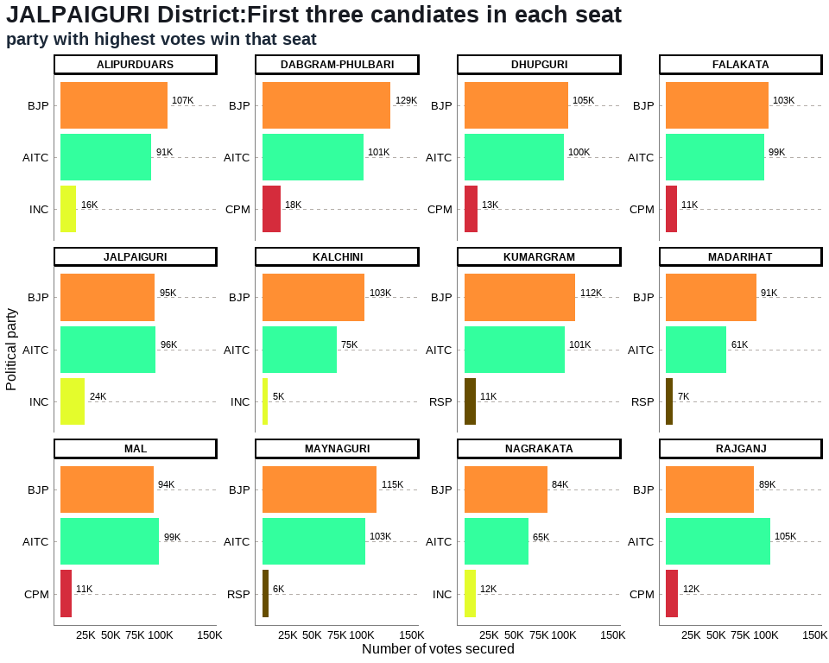

## Table 10: JALPAIGURI District Election Results: Top 3 Candidates by Votes in Each Constituency

| **Constituency** | **Type** | **Party** | **Candidate** | **Position** | **Votes** | **Margin** |
| --- | --- | --- | --- | --- | --- | --- |
| ALIPURDUARS | GEN | BJP | Suman Kanjilal | 1 | 107,333 | 16,007 |
| ALIPURDUARS | GEN | AITC | Sourav Chakraborty (Ghutis) | 2 | 91,326 | 75,675 |
| ALIPURDUARS | GEN | INC | Deba Prasad Roy | 3 | 15,651 | 13,300 |
| DABGRAM-PHULBARI | GEN | BJP | Sikha Chatterjee | 1 | 129,088 | 27,593 |
| DABGRAM-PHULBARI | GEN | AITC | Goutam Deb | 2 | 101,495 | 83,497 |
| DABGRAM-PHULBARI | GEN | CPM | Dilip Singh | 3 | 17,998 | 14,619 |
| DHUPGURI | SC | BJP | Bishnu Pada Ray | 1 | 104,688 | 4,355 |
| DHUPGURI | SC | AITC | Mitali Roy | 2 | 100,333 | 87,226 |
| DHUPGURI | SC | CPM | Pradip Kumar Roy | 3 | 13,107 | 10,929 |
| FALAKATA | SC | BJP | Dipak Barman | 1 | 102,993 | 3,990 |
| FALAKATA | SC | AITC | Subhash Chandra Roy | 2 | 99,003 | 88,231 |
| FALAKATA | SC | CPM | Kshitish Chandra Ray | 3 | 10,772 | 8,802 |
| JALPAIGURI | SC | AITC | Dr. Pradip Kumar Barma | 1 | 95,668 | 941 |
| JALPAIGURI | SC | BJP | Soujit Singha (Piku) | 2 | 94,727 | 70,499 |
| JALPAIGURI | SC | INC | Sukhbilas Barma | 3 | 24,228 | 20,847 |
| KALCHINI | ST | BJP | Bishal Lama | 1 | 103,104 | 28,576 |
| KALCHINI | ST | AITC | Passang Lama | 2 | 74,528 | 69,046 |
| KALCHINI | ST | INC | Avijit Narjinary | 3 | 5,482 | 3,057 |
| KUMARGRAM | ST | BJP | Manoj Kumar Oraon | 1 | 111,974 | 11,001 |
| KUMARGRAM | ST | AITC | Leos Kujur (Urao) | 2 | 100,973 | 89,720 |
| KUMARGRAM | ST | RSP | Kishor Minj | 3 | 11,253 | 8,535 |
| MADARIHAT | ST | BJP | Manoj Tigga | 1 | 90,718 | 29,685 |
| MADARIHAT | ST | AITC | Rajesh Lakra | 2 | 61,033 | 53,961 |
| MADARIHAT | ST | RSP | Subhash Lohar | 3 | 7,072 | 4,450 |
| MAL | ST | AITC | Bulu Chik Baraik | 1 | 99,086 | 5,465 |
| MAL | ST | BJP | Mahesh Bagey | 2 | 93,621 | 82,692 |
| MAL | ST | CPM | Manu Oraon | 3 | 10,929 | 6,230 |
| MAYNAGURI | SC | BJP | Kaushik Roy | 1 | 115,306 | 11,911 |
| MAYNAGURI | SC | AITC | Manoj Roy | 2 | 103,395 | 97,635 |
| MAYNAGURI | SC | RSP | Naresh Chandra Roy | 3 | 5,760 | 2,665 |
| NAGRAKATA | ST | BJP | Puna Bhengra | 1 | 83,707 | 19,038 |
| NAGRAKATA | ST | AITC | Joseph Munda | 2 | 64,669 | 53,068 |
| NAGRAKATA | ST | INC | Sukbir Subba | 3 | 11,601 | 6,675 |
| RAJGANJ | SC | AITC | Khageswar Roy | 1 | 104,641 | 15,773 |
| RAJGANJ | SC | BJP | Supen Roy | 2 | 88,868 | 76,760 |
| RAJGANJ | SC | CPM | Ratan Kumar Roy | 3 | 12,108 | 8,933 |

## Annex 10: KOLKATA CORPORATION DISTRICT

## 10. KOLKATA CORPORATION District: Winners per constituency and top 3 candidates

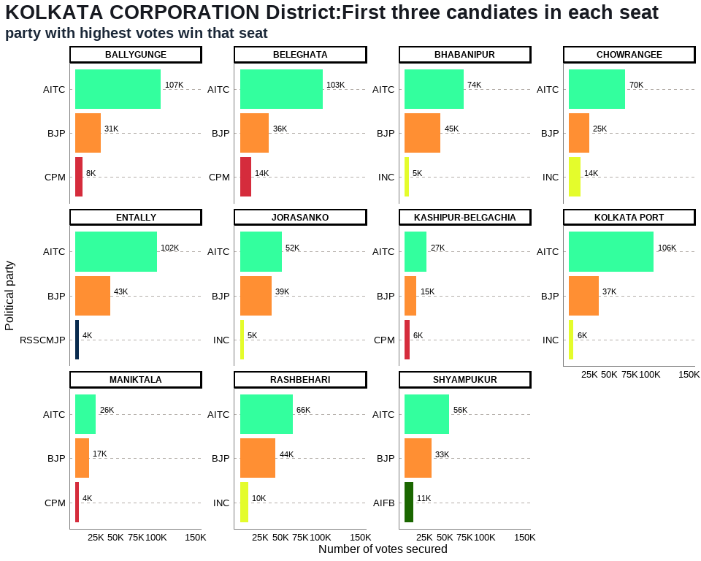

## Table 11: KOLKATA CORPORATION District Election Results: Top 3 Candidates by Votes in Each Constituency

| **Constituency** | **Type** | **Party** | **Candidate** | **Position** | **Votes** | **Margin** |
| --- | --- | --- | --- | --- | --- | --- |
| BALLYGUNGE | GEN | AITC | Subrata Mukherjee | 1 | 106,585 | 75,359 |
| BALLYGUNGE | GEN | BJP | Lokenath Chatterjee | 2 | 31,226 | 22,752 |
| BALLYGUNGE | GEN | CPM | Dr. Fuad Halim | 3 | 8,474 | 7,157 |
| BELEGHATA | GEN | AITC | Paresh Paul | 1 | 103,182 | 67,140 |
| BELEGHATA | GEN | BJP | Kashinath Biswas | 2 | 36,042 | 21,997 |
| BELEGHATA | GEN | CPM | Rajib Biswas | 3 | 14,045 | 12,481 |
| BHABANIPUR | GEN | AITC | Sobhandeb Chattopadhyay | 1 | 73,505 | 28,719 |
| BHABANIPUR | GEN | BJP | Rudranil Ghosh | 2 | 44,786 | 39,575 |
| BHABANIPUR | GEN | INC | Md. Shadab Khan | 3 | 5,211 | 3,641 |
| CHOWRANGEE | GEN | AITC | Bandyopadhyay Nayna | 1 | 70,101 | 45,344 |
| CHOWRANGEE | GEN | BJP | Devdutta Maji | 2 | 24,757 | 10,491 |
| CHOWRANGEE | GEN | INC | Santosh Kumar Pathak | 3 | 14,266 | 13,054 |
| ENTALLY | GEN | AITC | Swarna Kamal Saha | 1 | 101,709 | 58,257 |
| ENTALLY | GEN | BJP | Priyanka Tibrewal | 2 | 43,452 | 39,098 |
| ENTALLY | GEN | RSSCMJP | Md. Iqbal Alam | 3 | 4,354 | 2,420 |
| JORASANKO | GEN | AITC | Vivek Gupta | 1 | 52,123 | 12,743 |
| JORASANKO | GEN | BJP | Meena Devi Purohit | 2 | 39,380 | 34,611 |
| JORASANKO | GEN | INC | Ajmal Khan | 3 | 4,769 | 3,741 |
| KASHIPUR-BELGACHIA | GEN | AITC | Atin Ghosh | 1 | 27,482 | 12,786 |
| KASHIPUR-BELGACHIA | GEN | BJP | Sibaji Sinha Roy | 2 | 14,696 | 8,495 |
| KASHIPUR-BELGACHIA | GEN | CPM | Pratip Dasgupta | 3 | 6,201 | 5,649 |
| KOLKATA PORT | GEN | AITC | Firhad Hakim | 1 | 105,543 | 68,554 |
| KOLKATA PORT | GEN | BJP | Awadh Kishore Gupta | 2 | 36,989 | 31,399 |
| KOLKATA PORT | GEN | INC | Md Mukhtar | 3 | 5,590 | 4,230 |
| MANIKTALA | GEN | AITC | Sadhan Pande | 1 | 25,589 | 8,490 |
| MANIKTALA | GEN | BJP | Kalyan Chaubey | 2 | 17,099 | 12,677 |
| MANIKTALA | GEN | CPM | Rupa Bagchi | 3 | 4,422 | 3,874 |
| RASHBEHARI | GEN | AITC | Debasish Kumar | 1 | 65,704 | 21,414 |
| RASHBEHARI | GEN | BJP | Lt. Gen. (Dr.) Subrata Saha | 2 | 44,290 | 33,976 |
| RASHBEHARI | GEN | INC | Ashutosh Chatterjee | 3 | 10,314 | 8,652 |
| SHYAMPUKUR | GEN | AITC | Dr. Shashi Panja | 1 | 55,785 | 22,520 |
| SHYAMPUKUR | GEN | BJP | Sandipan Biswas | 2 | 33,265 | 22,437 |
| SHYAMPUKUR | GEN | AIFB | Jiban Prakash Saha | 3 | 10,828 | 9,765 |

## Annex 11: MALDAH DISTRICT

## 11. MALDAH District: Winners per constituency and top 3 candidates

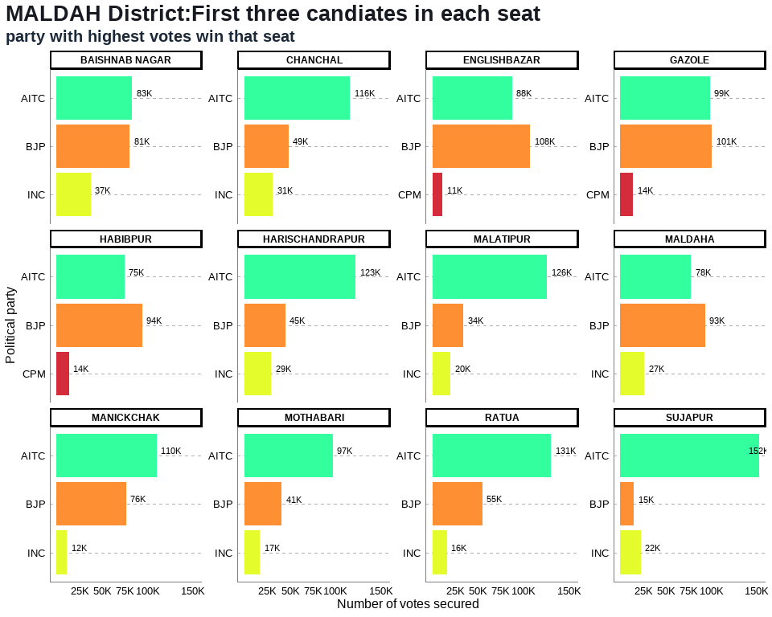

## Table 12: MALDAH District Election Results: Top 3 Candidates by Votes in Each Constituency

| **Constituency** | **Type** | **Party** | **Candidate** | **Position** | **Votes** | **Margin** |
| --- | --- | --- | --- | --- | --- | --- |
| BAISHNAB NAGAR | GEN | AITC | Chandana Sarkar | 1 | 83,061 | 2,471 |
| BAISHNAB NAGAR | GEN | BJP | Swadhin Kumar Sarkar | 2 | 80,590 | 43,147 |
| BAISHNAB NAGAR | GEN | INC | Azizul Hoque | 3 | 37,443 | 35,161 |
| CHANCHAL | GEN | AITC | Nihar Ranjan Ghosh | 1 | 115,966 | 67,338 |
| CHANCHAL | GEN | BJP | Dipankar Ram (Bankat) | 2 | 48,628 | 17,282 |
| CHANCHAL | GEN | INC | Asif Mehbub | 3 | 31,346 | 30,132 |
| ENGLISHBAZAR | GEN | BJP | Sreerupa Mitra Chaudhury(Nirbhoy Didi) | 1 | 107,755 | 20,099 |
| ENGLISHBAZAR | GEN | AITC | Krishnendu Narayan Choudhury | 2 | 87,656 | 76,703 |
| ENGLISHBAZAR | GEN | CPM | Koushik Misra(Saheb) | 3 | 10,953 | 7,757 |
| GAZOLE | SC | BJP | Chinmoy Deb Barman | 1 | 100,655 | 1,798 |
| GAZOLE | SC | AITC | Basanti Barman | 2 | 98,857 | 84,907 |
| GAZOLE | SC | CPM | Arun Kumar Biswas | 3 | 13,950 | 12,007 |
| HABIBPUR | ST | BJP | Joyel Murmu | 1 | 94,075 | 19,517 |
| HABIBPUR | ST | AITC | Prodip Baskey | 2 | 74,558 | 60,753 |
| HABIBPUR | ST | CPM | Thakur Tudu | 3 | 13,805 | 7,909 |
| HARISCHANDRAPUR | GEN | AITC | Tajmul Hossain | 1 | 122,527 | 77,473 |
| HARISCHANDRAPUR | GEN | BJP | Md. Matibur Rahaman | 2 | 45,054 | 15,658 |
| HARISCHANDRAPUR | GEN | INC | Alam Mostaque | 3 | 29,396 | 27,923 |
| MALATIPUR | GEN | AITC | Abdur Rahim Boxi | 1 | 126,157 | 91,949 |
| MALATIPUR | GEN | BJP | Mousumi Das | 2 | 34,208 | 14,381 |
| MALATIPUR | GEN | INC | Alberuni Zulkarnain | 3 | 19,827 | 17,793 |
| MALDAHA | SC | BJP | Gopal Chandra Saha | 1 | 93,398 | 15,456 |
| MALDAHA | SC | AITC | Ujjwal Kumar Chowdhury | 2 | 77,942 | 51,379 |
| MALDAHA | SC | INC | Bhupendra Nath Halder (Arjun) | 3 | 26,563 | 23,745 |
| MANICKCHAK | GEN | AITC | Sabitri Mitra | 1 | 110,234 | 33,878 |
| MANICKCHAK | GEN | BJP | Gour Chandra Mandal | 2 | 76,356 | 64,801 |
| MANICKCHAK | GEN | INC | Alam Mottakin | 3 | 11,555 | 8,812 |
| MOTHABARI | GEN | AITC | Yeasmin Sabina | 1 | 97,397 | 56,573 |
| MOTHABARI | GEN | BJP | Shyamchand Ghosh | 2 | 40,824 | 23,921 |
| MOTHABARI | GEN | INC | Dulal Sk | 3 | 16,903 | 13,318 |
| RATUA | GEN | AITC | Samar Mukherjee | 1 | 130,674 | 75,650 |
| RATUA | GEN | BJP | Abishek Singhania | 2 | 55,024 | 38,851 |
| RATUA | GEN | INC | Khatun Najema | 3 | 16,173 | 7,545 |
| SUJAPUR | GEN | AITC | Md Abdul Ghani | 1 | 152,445 | 130,163 |
| SUJAPUR | GEN | INC | Isha Khan Choudhury | 2 | 22,282 | 7,493 |
| SUJAPUR | GEN | BJP | Sk Ziauddin | 3 | 14,789 | 3,616 |

## Annex 12: MURSHIDABAD DISTRICT

## 12. MURSHIDABAD District: Winners per constituency and top 3 candidates

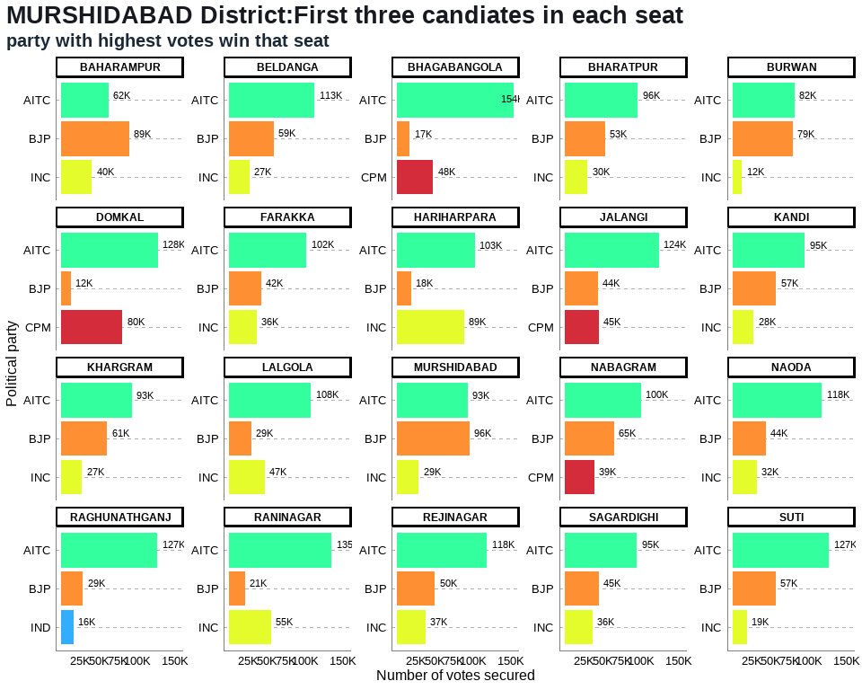

## Table 13: MURSHIDABAD District Election Results: Top 3 Candidates by Votes in Each Constituency

| **Constituency** | **Type** | **Party** | **Candidate** | **Position** | **Votes** | **Margin** |
| --- | --- | --- | --- | --- | --- | --- |
| BAHARAMPUR | GEN | BJP | Subrata Maitra (Kanchan) | 1 | 89,340 | 26,852 |
| BAHARAMPUR | GEN | AITC | Naru Gopal Mukherjee | 2 | 62,488 | 22,321 |
| BAHARAMPUR | GEN | INC | Manoj Chakraborty | 3 | 40,167 | 37,642 |
| BELDANGA | GEN | AITC | Hasanuzzaman Sk | 1 | 112,862 | 53,832 |
| BELDANGA | GEN | BJP | Sumit Ghosh | 2 | 59,030 | 32,081 |
| BELDANGA | GEN | INC | Safiujjaman Seikh | 3 | 26,949 | 24,981 |
| BHAGABANGOLA | GEN | AITC | Idris Ali | 1 | 153,795 | 106,008 |
| BHAGABANGOLA | GEN | CPM | Md. Kamal Hossain | 2 | 47,787 | 31,080 |
| BHAGABANGOLA | GEN | BJP | Mehebub Alam | 3 | 16,707 | 13,311 |
| BHARATPUR | GEN | AITC | Humayun Kabir | 1 | 96,226 | 43,083 |
| BHARATPUR | GEN | BJP | Iman Kalyan Mukherjee | 2 | 53,143 | 23,027 |
| BHARATPUR | GEN | INC | Kamalesh Chatterjee (Gopal) | 3 | 30,116 | 27,535 |
| BURWAN | SC | AITC | Jiban Krishna Saha | 1 | 81,890 | 2,749 |
| BURWAN | SC | BJP | Amiya Kumar Das | 2 | 79,141 | 66,881 |
| BURWAN | SC | INC | Shiladitya Haldar | 3 | 12,260 | 10,252 |
| DOMKAL | GEN | AITC | Jafikul Islam | 1 | 127,671 | 47,229 |
| DOMKAL | GEN | CPM | Md. Mostafijur Rahaman (Rana) | 2 | 80,442 | 68,094 |
| DOMKAL | GEN | BJP | Biyamma Mondal (Rubia) | 3 | 12,348 | 9,929 |
| FARAKKA | GEN | AITC | Manirul Islam | 1 | 102,319 | 59,945 |
| FARAKKA | GEN | BJP | Ghosh Hemanta | 2 | 42,374 | 6,169 |
| FARAKKA | GEN | INC | Mainul Haque | 3 | 36,205 | 34,558 |
| HARIHARPARA | GEN | AITC | Niamot Sheikh | 1 | 102,660 | 14,066 |
| HARIHARPARA | GEN | INC | Mir Alamgir (Palash) | 2 | 88,594 | 70,216 |
| HARIHARPARA | GEN | BJP | Tanmoy Biswas | 3 | 18,378 | 16,653 |
| JALANGI | GEN | AITC | Abdur Razzak | 1 | 123,840 | 79,276 |
| JALANGI | GEN | CPM | Saiful Islam Molla | 2 | 44,564 | 791 |
| JALANGI | GEN | BJP | Chandan Mandal | 3 | 43,773 | 39,584 |
| KANDI | GEN | AITC | Apurba Sarkar (David) | 1 | 95,399 | 38,080 |
| KANDI | GEN | BJP | Goutam Roy | 2 | 57,319 | 29,764 |
| KANDI | GEN | INC | Shafiul Alam Khan (Bonu) | 3 | 27,555 | 24,424 |
| KHARGRAM | SC | AITC | Ashis Marjit | 1 | 93,255 | 32,573 |
| KHARGRAM | SC | BJP | Aditya Moulik | 2 | 60,682 | 33,259 |
| KHARGRAM | SC | INC | Bipad Taran Bagdi | 3 | 27,423 | 25,738 |
| LALGOLA | GEN | AITC | Ali Mohammad | 1 | 107,860 | 60,707 |
| LALGOLA | GEN | INC | Abu Hena | 2 | 47,153 | 17,689 |
| LALGOLA | GEN | BJP | Kalpana Ghosh | 3 | 29,464 | 27,773 |
| MURSHIDABAD | GEN | BJP | Gouri Sankar Ghosh | 1 | 95,967 | 2,491 |
| MURSHIDABAD | GEN | AITC | Shaoni Singha Roy | 2 | 93,476 | 64,641 |
| MURSHIDABAD | GEN | INC | Neajuddin Sk | 3 | 28,835 | 25,931 |
| NABAGRAM | SC | AITC | Kanai Chandra Mondal | 1 | 100,455 | 35,533 |
| NABAGRAM | SC | BJP | Mohan Halder | 2 | 64,922 | 25,793 |
| NABAGRAM | SC | CPM | Kripalini Ghosh | 3 | 39,129 | 36,500 |
| NAODA | GEN | AITC | Sahina Momtaz Khan | 1 | 117,684 | 74,153 |
| NAODA | GEN | BJP | Anupam Mandal | 2 | 43,531 | 11,943 |
| NAODA | GEN | INC | Mosaraf Hossain Mondal (Madhu) | 3 | 31,588 | 27,195 |
| RAGHUNATHGANJ | GEN | AITC | Akhruzzaman | 1 | 126,834 | 98,313 |
| RAGHUNATHGANJ | GEN | BJP | Golam Modaswer | 2 | 28,521 | 12,277 |
| RAGHUNATHGANJ | GEN | IND | Nasir Saikh | 3 | 16,244 | 3,445 |
| RANINAGAR | GEN | AITC | Abdul Soumik Hossain | 1 | 134,957 | 79,702 |
| RANINAGAR | GEN | INC | Firoza Begam | 2 | 55,255 | 34,117 |
| RANINAGAR | GEN | BJP | Mst Masuara Khatun | 3 | 21,138 | 18,364 |
| REJINAGAR | GEN | AITC | Rabiul Alam Chowdhury | 1 | 118,494 | 68,268 |
| REJINAGAR | GEN | BJP | Arabinda Biswas | 2 | 50,226 | 12,944 |
| REJINAGAR | GEN | INC | Kafiruddin Sk | 3 | 37,282 | 35,722 |
| SAGARDIGHI | GEN | AITC | Subrata Saha | 1 | 95,189 | 50,206 |
| SAGARDIGHI | GEN | BJP | Khatun Mafuja | 2 | 44,983 | 8,639 |
| SAGARDIGHI | GEN | INC | Sk M Hasanuzzaman (Bappa) | 3 | 36,344 | 32,894 |
| SUTI | GEN | AITC | Emani Biswas | 1 | 127,351 | 70,701 |
| SUTI | GEN | BJP | Koushik Das | 2 | 56,650 | 37,890 |
| SUTI | GEN | INC | Humayun Reza | 3 | 18,760 | 10,754 |

## Annex 13: NADIA DISTRICT

## 13. NADIA District: Winners per constituency and top 3 candidates

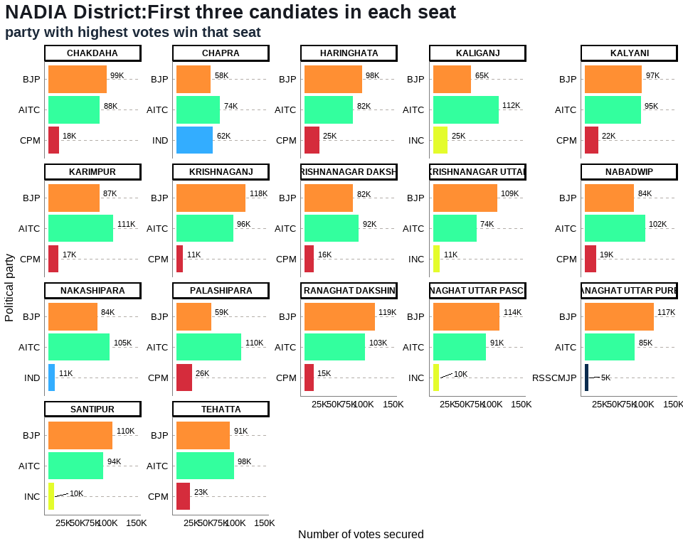

## Table 14: NADIA District Election Results: Top 3 Candidates by Votes in Each Constituency

| **Constituency** | **Type** | **Party** | **Candidate** | **Position** | **Votes** | **Margin** |
| --- | --- | --- | --- | --- | --- | --- |
| CHAKDAHA | GEN | BJP | Bankim Chandra Ghosh | 1 | 99,368 | 11,680 |
| CHAKDAHA | GEN | AITC | Subhankar Singha (Jishu) | 2 | 87,688 | 69,876 |
| CHAKDAHA | GEN | CPM | Narayan Das Gupta | 3 | 17,812 | 16,129 |
| CHAPRA | GEN | AITC | Rukbanur Rahman | 1 | 73,866 | 12,118 |
| CHAPRA | GEN | IND | Jeber Sekh | 2 | 61,748 | 3,580 |
| CHAPRA | GEN | BJP | Kalyan Kumar Nandi | 3 | 58,168 | 46,446 |
| HARINGHATA | SC | BJP | Asim Kumar Sarkar | 1 | 97,666 | 15,200 |
| HARINGHATA | SC | AITC | Nilima Nag (Mallick) | 2 | 82,466 | 57,666 |
| HARINGHATA | SC | CPM | Alakesh Das | 3 | 24,800 | 23,373 |
| KALIGANJ | GEN | AITC | Nasiruddin Ahamed (Lal) | 1 | 111,696 | 46,987 |
| KALIGANJ | GEN | BJP | Abhijit Ghosh | 2 | 64,709 | 39,633 |
| KALIGANJ | GEN | INC | Abul Kashem | 3 | 25,076 | 23,025 |
| KALYANI | SC | BJP | Ambika Roy | 1 | 97,026 | 2,206 |
| KALYANI | SC | AITC | Aniruddha Biswas | 2 | 94,820 | 72,655 |
| KALYANI | SC | CPM | Sabuj Das | 3 | 22,165 | 19,588 |
| KARIMPUR | GEN | AITC | Bimalendu Sinha Roy | 1 | 110,911 | 23,575 |
| KARIMPUR | GEN | BJP | Samarendranath Ghosh | 2 | 87,336 | 70,151 |
| KARIMPUR | GEN | CPM | Prabhas Majumdar | 3 | 17,185 | 15,716 |
| KRISHNAGANJ | SC | BJP | Ashis Kumar Biswas | 1 | 117,668 | 21,277 |
| KRISHNAGANJ | SC | AITC | Dr. Tapas Mandal | 2 | 96,391 | 85,478 |
| KRISHNAGANJ | SC | CPM | Jhunu Baidya | 3 | 10,913 | 8,814 |
| KRISHNANAGAR DAKSHIN | GEN | AITC | Ujjal Biswas | 1 | 91,738 | 9,305 |
| KRISHNANAGAR DAKSHIN | GEN | BJP | Mahadev Sarkar | 2 | 82,433 | 66,827 |
| KRISHNANAGAR DAKSHIN | GEN | CPM | Biswas Sumit | 3 | 15,606 | 13,441 |
| KRISHNANAGAR UTTAR | GEN | BJP | Mukul Roy | 1 | 109,357 | 35,089 |
| KRISHNANAGAR UTTAR | GEN | AITC | Koushani Mukherjee | 2 | 74,268 | 62,861 |
| KRISHNANAGAR UTTAR | GEN | INC | Silvi Saha | 3 | 11,407 | 9,556 |
| NABADWIP | GEN | AITC | Pundarikakshya Saha | 1 | 102,170 | 18,571 |
| NABADWIP | GEN | BJP | Sidhartha Shankar Naskar | 2 | 83,599 | 65,059 |
| NABADWIP | GEN | CPM | Swarnendu Sinha | 3 | 18,540 | 16,196 |
| NAKASHIPARA | GEN | AITC | Kallol Khan | 1 | 104,812 | 21,271 |
| NAKASHIPARA | GEN | BJP | Santanu Dey | 2 | 83,541 | 72,264 |
| NAKASHIPARA | GEN | IND | Tanmay Ganguli | 3 | 11,277 | 5,912 |
| PALASHIPARA | GEN | AITC | Dr. Manik Bhattacharya | 1 | 110,274 | 51,336 |
| PALASHIPARA | GEN | BJP | Bibhash Chandra Mandal | 2 | 58,938 | 32,710 |
| PALASHIPARA | GEN | CPM | S.m. Sadi | 3 | 26,228 | 24,532 |
| RANAGHAT DAKSHIN | SC | BJP | Mukut Mani Adhikari | 1 | 119,260 | 16,515 |
| RANAGHAT DAKSHIN | SC | AITC | Barnali Dey Roy | 2 | 102,745 | 87,621 |
| RANAGHAT DAKSHIN | SC | CPM | Rama Biswas | 3 | 15,124 | 13,458 |
| RANAGHAT UTTAR PASCHIM | GEN | BJP | Parthasarathi Chatterjee | 1 | 113,637 | 23,128 |
| RANAGHAT UTTAR PASCHIM | GEN | AITC | Sankar Singha | 2 | 90,509 | 80,164 |
| RANAGHAT UTTAR PASCHIM | GEN | INC | Bijayendu Biswas (Habu) | 3 | 10,345 | 8,087 |
| RANAGHAT UTTAR PURBA | SC | BJP | Ashim Biswas | 1 | 116,786 | 31,782 |
| RANAGHAT UTTAR PURBA | SC | AITC | Samir Kumar Poddar | 2 | 85,004 | 79,800 |
| RANAGHAT UTTAR PURBA | SC | RSSCMJP | Dinesh Chandra Biswas | 3 | 5,204 | 2,845 |
| SANTIPUR | GEN | BJP | Jagannath Sarkar | 1 | 109,722 | 15,878 |
| SANTIPUR | GEN | AITC | Ajoy Dey | 2 | 93,844 | 83,996 |
| SANTIPUR | GEN | INC | Ritzu Ghosal | 3 | 9,848 | 7,463 |
| TEHATTA | GEN | AITC | Tapas Kumar Saha | 1 | 97,848 | 6,915 |
| TEHATTA | GEN | BJP | Ashutosh Paul | 2 | 90,933 | 67,694 |
| TEHATTA | GEN | CPM | Subodh Chandra Biswas | 3 | 23,239 | 21,363 |

## Annex 14: NORTH 24 PARGANAS DISTRICT

## 14. NORTH 24 PARGANAS District: Winners per constituency and top 3 candidates

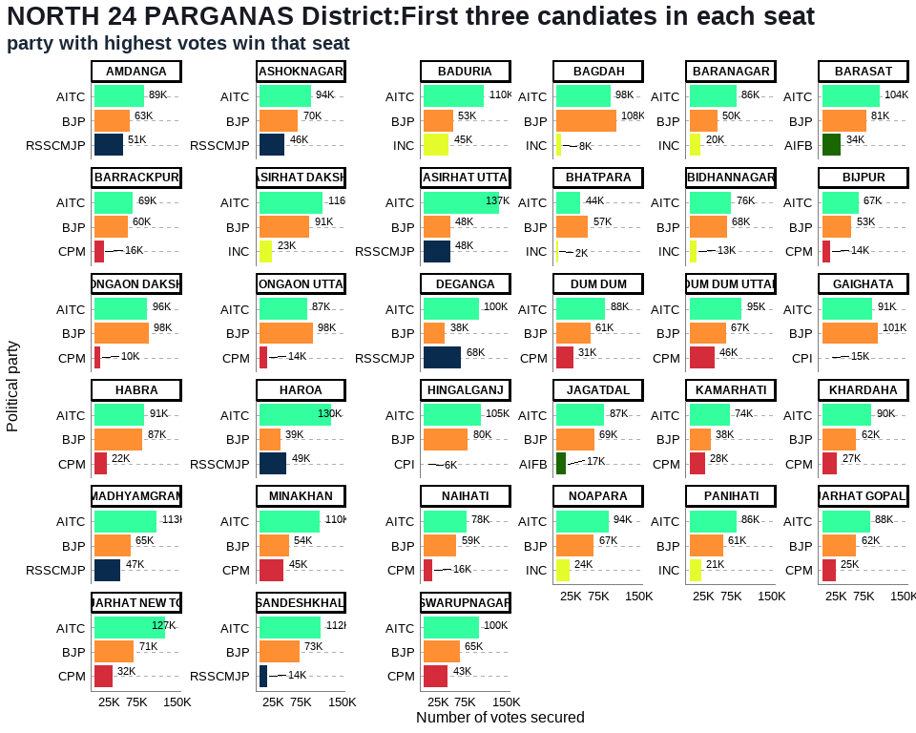

## Table 15: NORTH 24 PARGANAS District Election Results: Top 3 Candidates by Votes in Each Constituency

| **Constituency** | **Type** | **Party** | **Candidate** | **Position** | **Votes** | **Margin** |
| --- | --- | --- | --- | --- | --- | --- |
| AMDANGA | GEN | AITC | Rafiqur Rahaman | 1 | 88,935 | 25,480 |
| AMDANGA | GEN | BJP | Joydev Manna | 2 | 63,455 | 12,550 |
| AMDANGA | GEN | RSSCMJP | Jamal Uddin | 3 | 50,905 | 48,581 |
| ASHOKNAGAR | GEN | AITC | Narayan Goswami | 1 | 93,587 | 23,532 |
| ASHOKNAGAR | GEN | BJP | Tanuja Chakraborty | 2 | 70,055 | 24,260 |
| ASHOKNAGAR | GEN | RSSCMJP | Tapas Banerjee | 3 | 45,795 | 44,184 |
| BADURIA | GEN | AITC | Abdur Rahim Quazi | 1 | 109,701 | 56,444 |
| BADURIA | GEN | BJP | Sukalyan Baidya | 2 | 53,257 | 8,026 |
| BADURIA | GEN | INC | Abdus Sattar | 3 | 45,231 | 43,278 |
| BAGDAH | SC | BJP | Biswajit Das | 1 | 108,111 | 9,792 |
| BAGDAH | SC | AITC | Paritosh Kumar Saha | 2 | 98,319 | 90,069 |
| BAGDAH | SC | INC | Kirttaniya Prabir (Bapi) | 3 | 8,250 | 6,010 |
| BARANAGAR | GEN | AITC | Tapas Roy | 1 | 85,615 | 35,147 |
| BARANAGAR | GEN | BJP | Parno Mittra | 2 | 50,468 | 30,333 |
| BARANAGAR | GEN | INC | Amal Kumar Mukhopadhyay | 3 | 20,135 | 17,757 |
| BARASAT | GEN | AITC | Chiranjeet Chakrabarti | 1 | 104,431 | 23,783 |
| BARASAT | GEN | BJP | Sankar Chatterjee | 2 | 80,648 | 46,477 |
| BARASAT | GEN | AIFB | Sanjib Chattopadhyay | 3 | 34,171 | 31,483 |
| BARRACKPUR | GEN | AITC | Raju Chakraborty (Raj) | 1 | 68,887 | 9,222 |
| BARRACKPUR | GEN | BJP | Chandramani Shukla | 2 | 59,665 | 43,520 |
| BARRACKPUR | GEN | CPM | Debasish Bhowmick | 3 | 16,145 | 14,215 |
| BASIRHAT DAKSHIN | GEN | AITC | Dr. Saptarshi Banerjee | 1 | 115,873 | 24,468 |
| BASIRHAT DAKSHIN | GEN | BJP | Tarak Nath Ghosh | 2 | 91,405 | 68,316 |
| BASIRHAT DAKSHIN | GEN | INC | Amit Majumdar | 3 | 23,089 | 21,400 |
| BASIRHAT UTTAR | GEN | AITC | Rafikul Islam Mondal | 1 | 137,216 | 89,351 |
| BASIRHAT UTTAR | GEN | RSSCMJP | Md Baijid Amin | 2 | 47,865 | 360 |
| BASIRHAT UTTAR | GEN | BJP | Narayan Chandra Mondal | 3 | 47,505 | 45,491 |
| BHATPARA | GEN | BJP | Pawan Kumar Singh | 1 | 57,244 | 13,687 |
| BHATPARA | GEN | AITC | Jitendra Shaw (Jitu) | 2 | 43,557 | 41,388 |
| BHATPARA | GEN | INC | Dharmendra Shaw | 3 | 2,169 | 1,009 |
| BIDHANNAGAR | GEN | AITC | Sujit Bose S/O - Late Ajit Bose | 1 | 75,912 | 7,997 |
| BIDHANNAGAR | GEN | BJP | Sabya Sachi Dutta S/O - Late Gouri Sankar Dutta | 2 | 67,915 | 55,094 |
| BIDHANNAGAR | GEN | INC | Abhisek Banerjee | 3 | 12,821 | 10,608 |
| BIJPUR | GEN | AITC | Subodh Adhikary | 1 | 66,625 | 13,347 |
| BIJPUR | GEN | BJP | Subhranshu Roy | 2 | 53,278 | 38,788 |
| BIJPUR | GEN | CPM | Sukanta Rakshit (Babin) | 3 | 14,490 | 12,948 |
| BONGAON DAKSHIN | SC | BJP | Swapan Majumder | 1 | 97,828 | 2,004 |
| BONGAON DAKSHIN | SC | AITC | Alo Rani Sarkar | 2 | 95,824 | 85,755 |
| BONGAON DAKSHIN | SC | CPM | Tapas Kumar Biswas | 3 | 10,069 | 8,527 |
| BONGAON UTTAR | SC | BJP | Ashok Kirtania | 1 | 97,761 | 10,488 |
| BONGAON UTTAR | SC | AITC | Shyamal Roy | 2 | 87,273 | 73,222 |
| BONGAON UTTAR | SC | CPM | Pijush Kanti Saha | 3 | 14,051 | 12,218 |
| DEGANGA | GEN | AITC | Rahima Mondal | 1 | 100,105 | 32,537 |
| DEGANGA | GEN | RSSCMJP | Karim Ali | 2 | 67,568 | 29,122 |
| DEGANGA | GEN | BJP | Dipika Chattarjee | 3 | 38,446 | 35,504 |
| DUM DUM | GEN | AITC | Brtya Basu | 1 | 87,999 | 26,731 |
| DUM DUM | GEN | BJP | Bimalshankar Nanda | 2 | 61,268 | 30,615 |
| DUM DUM | GEN | CPM | Palash Das | 3 | 30,653 | 28,614 |
| DUM DUM UTTAR | GEN | AITC | Chandrima Bhattacharya | 1 | 95,465 | 28,499 |
| DUM DUM UTTAR | GEN | BJP | Dr. Archana Majumdar | 2 | 66,966 | 21,238 |
| DUM DUM UTTAR | GEN | CPM | Tanmoy Bhattacharya | 3 | 45,728 | 43,617 |
| GAIGHATA | SC | BJP | Subrata Thakur | 1 | 100,808 | 9,578 |
| GAIGHATA | SC | AITC | Narottam Biswas | 2 | 91,230 | 76,392 |
| GAIGHATA | SC | CPI | Kapil Krishna Thakur | 3 | 14,838 | 13,312 |
| HABRA | GEN | AITC | Jyoti Priya Mallick | 1 | 90,533 | 3,841 |
| HABRA | GEN | BJP | Biswajit Sinha | 2 | 86,692 | 64,698 |
| HABRA | GEN | CPM | Rijinandan Biswas | 3 | 21,994 | 20,704 |
| HAROA | GEN | AITC | Islam Sk Nurul (Haji) | 1 | 130,398 | 80,978 |
| HAROA | GEN | RSSCMJP | Kutubuddin Fathe | 2 | 49,420 | 10,914 |
| HAROA | GEN | BJP | Rajendra Saha (Somu) | 3 | 38,506 | 35,576 |
| HINGALGANJ | SC | AITC | Debes Mandal | 1 | 104,706 | 24,916 |
| HINGALGANJ | SC | BJP | Nemai Das | 2 | 79,790 | 73,782 |
| HINGALGANJ | SC | CPI | Ranjan Kumar Mondal | 3 | 6,008 | 4,272 |
| JAGATDAL | GEN | AITC | Somenath Shyam Ichini | 1 | 87,030 | 18,364 |
| JAGATDAL | GEN | BJP | Arindam Bhattacharya | 2 | 68,666 | 51,918 |
| JAGATDAL | GEN | AIFB | Nemai Saha | 3 | 16,748 | 14,180 |
| KAMARHATI | GEN | AITC | Madan Mitra | 1 | 73,845 | 35,408 |
| KAMARHATI | GEN | BJP | Anindya Banerjee | 2 | 38,437 | 10,127 |
| KAMARHATI | GEN | CPM | Sayandeep Mitra | 3 | 28,310 | 26,757 |
| KHARDAHA | GEN | AITC | Kajal Sinha | 1 | 89,807 | 28,140 |
| KHARDAHA | GEN | BJP | Silbhadra Datta | 2 | 61,667 | 34,751 |
| KHARDAHA | GEN | CPM | Debajyoti Das (Subho) | 3 | 26,916 | 24,501 |
| MADHYAMGRAM | GEN | AITC | Rathin Ghosh | 1 | 112,741 | 48,126 |
| MADHYAMGRAM | GEN | BJP | Rajasree Rajbanshi | 2 | 64,615 | 17,867 |
| MADHYAMGRAM | GEN | RSSCMJP | Biswajit Maity | 3 | 46,748 | 43,596 |
| MINAKHAN | SC | AITC | Usha Rani Mondal | 1 | 109,818 | 55,830 |
| MINAKHAN | SC | BJP | Jayanta Mondal | 2 | 53,988 | 9,382 |
| MINAKHAN | SC | CPM | Pradyut Roy | 3 | 44,606 | 40,666 |
| NAIHATI | GEN | AITC | Partha Bhowmick | 1 | 77,753 | 18,855 |
| NAIHATI | GEN | BJP | Phalguni Patra | 2 | 58,898 | 43,073 |
| NAIHATI | GEN | CPM | Indrani Kundu Mukherjee | 3 | 15,825 | 14,124 |
| NOAPARA | GEN | AITC | Manju Basu | 1 | 94,203 | 26,710 |
| NOAPARA | GEN | BJP | Sunil Singh | 2 | 67,493 | 43,991 |
| NOAPARA | GEN | INC | Subhankar Sarkar | 3 | 23,502 | 20,616 |
| PANIHATI | GEN | AITC | Nirmal Ghosh | 1 | 86,495 | 25,177 |
| PANIHATI | GEN | BJP | Sanmoy Bandyopadhyay | 2 | 61,318 | 40,149 |
| PANIHATI | GEN | INC | Tapas Majumder | 3 | 21,169 | 18,835 |
| RAJARHAT GOPALPUR | GEN | AITC | Aditi Munshi | 1 | 87,650 | 25,296 |
| RAJARHAT GOPALPUR | GEN | BJP | Samik Bhattacharya | 2 | 62,354 | 37,843 |
| RAJARHAT GOPALPUR | GEN | CPM | Subhajit Dasgupta | 3 | 24,511 | 22,253 |
| RAJARHAT NEW TOWN | GEN | AITC | Tapash Chatterjee | 1 | 127,374 | 56,432 |
| RAJARHAT NEW TOWN | GEN | BJP | Bhaskar Roy S/O - Dulal Roy | 2 | 70,942 | 39,399 |
| RAJARHAT NEW TOWN | GEN | CPM | Saptarshi Deb | 3 | 31,543 | 29,511 |
| SANDESHKHALI | ST | AITC | Sukumar Mahata | 1 | 112,450 | 39,685 |
| SANDESHKHALI | ST | BJP | Dr. Bhaskar Sardar | 2 | 72,765 | 58,378 |
| SANDESHKHALI | ST | RSSCMJP | Barun Mahato | 3 | 14,387 | 11,931 |
| SWARUPNAGAR | SC | AITC | Bina Mondal | 1 | 99,784 | 34,800 |
| SWARUPNAGAR | SC | BJP | Brindaban Sarkar | 2 | 64,984 | 21,702 |
| SWARUPNAGAR | SC | CPM | Biswajit Mandal | 3 | 43,282 | 42,026 |

## Annex 15: PASCHIM MEDINIPUR DISTRICT

## 15. PASCHIM MEDINIPUR District: Winners per constituency and top 3 candidates

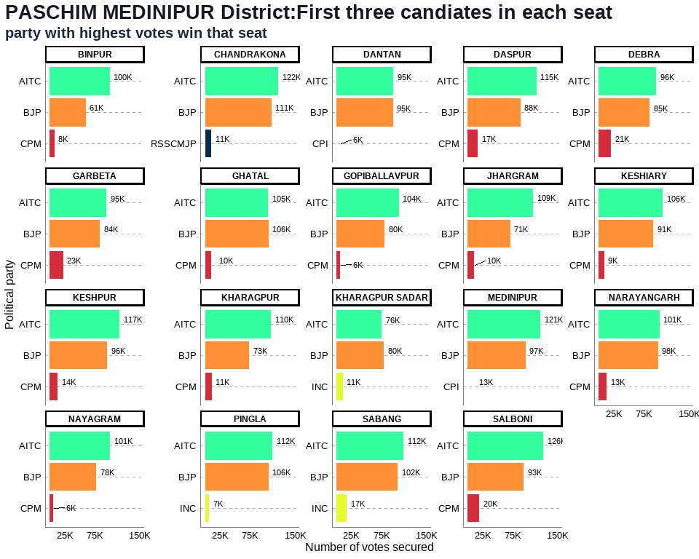

## Table 16: PASCHIM MEDINIPUR District Election Results: Top 3 Candidates by Votes in Each Constituency

| **Constituency** | **Type** | **Party** | **Candidate** | **Position** | **Votes** | **Margin** |
| --- | --- | --- | --- | --- | --- | --- |
| BINPUR | ST | AITC | Debnath Hansda | 1 | 100,277 | 39,494 |
| BINPUR | ST | BJP | Palan Saren | 2 | 60,783 | 52,430 |
| BINPUR | ST | CPM | Dibakar Hansda | 3 | 8,353 | 2,035 |
| CHANDRAKONA | SC | AITC | Arup Dhara | 1 | 121,846 | 11,281 |
| CHANDRAKONA | SC | BJP | Sibaram Das | 2 | 110,565 | 99,764 |
| CHANDRAKONA | SC | RSSCMJP | Gouranga Das | 3 | 10,801 | 7,895 |
| DANTAN | GEN | AITC | Bikram Chandra Pradhan | 1 | 95,209 | 623 |
| DANTAN | GEN | BJP | Saktipada Nayak | 2 | 94,586 | 88,934 |
| DANTAN | GEN | CPI | Sisir Kumar Patra | 3 | 5,652 | 4,402 |
| DASPUR | GEN | AITC | Mamata Bhunia | 1 | 114,753 | 26,842 |
| DASPUR | GEN | BJP | Prasanta Bera | 2 | 87,911 | 70,866 |
| DASPUR | GEN | CPM | Dhruba Sekhar Mandal | 3 | 17,045 | 15,658 |
| DEBRA | GEN | AITC | Humayun Kabir | 1 | 95,850 | 11,226 |
| DEBRA | GEN | BJP | Bharati Ghosh | 2 | 84,624 | 63,901 |
| DEBRA | GEN | CPM | Prankrishna Mondal | 3 | 20,723 | 19,214 |
| GARBETA | GEN | AITC | Uttara Singha (Hazra) | 1 | 94,928 | 10,572 |
| GARBETA | GEN | BJP | Madan Ruidas | 2 | 84,356 | 61,314 |
| GARBETA | GEN | CPM | Ghosh Kumar Tapan | 3 | 23,042 | 20,323 |
| GHATAL | SC | BJP | Sital Kapat | 1 | 105,812 | 966 |
| GHATAL | SC | AITC | Shankar Dolai | 2 | 104,846 | 94,681 |
| GHATAL | SC | CPM | Kamal Chandra Dolui | 3 | 10,165 | 8,157 |
| GOPIBALLAVPUR | GEN | AITC | Dr. Khagendra Nath Mahata | 1 | 104,115 | 23,768 |
| GOPIBALLAVPUR | GEN | BJP | Sanjit Mahata | 2 | 80,347 | 74,528 |
| GOPIBALLAVPUR | GEN | CPM | Prasanta Kumar Das | 3 | 5,819 | 3,028 |
| JHARGRAM | GEN | AITC | Birbaha Hansda | 1 | 109,493 | 38,240 |
| JHARGRAM | GEN | BJP | Sukhamay Satpathy (Jahar) | 2 | 71,253 | 60,823 |
| JHARGRAM | GEN | CPM | Madhuja Sen Roy | 3 | 10,430 | 6,794 |
| KESHIARY | ST | AITC | Paresh Murmu | 1 | 106,366 | 15,330 |
| KESHIARY | ST | BJP | Sonali Murmu Soren | 2 | 91,036 | 81,766 |
| KESHIARY | ST | CPM | Dr. Pulin Bihari Baske | 3 | 9,270 | 6,700 |
| KESHPUR | SC | AITC | Seuli Saha | 1 | 116,992 | 20,720 |
| KESHPUR | SC | BJP | Pritish Ranjan Kuar | 2 | 96,272 | 82,602 |
| KESHPUR | SC | CPM | Rameswar Doloi | 3 | 13,670 | 10,372 |
| KHARAGPUR | GEN | AITC | Dinen Roy | 1 | 109,727 | 36,230 |
| KHARAGPUR | GEN | BJP | Tapan Bhuya | 2 | 73,497 | 62,252 |
| KHARAGPUR | GEN | CPM | Syed Saddam Ali | 3 | 11,245 | 8,931 |
| KHARAGPUR SADAR | GEN | BJP | Hiranmoy Chattopadhyaya | 1 | 79,607 | 3,771 |
| KHARAGPUR SADAR | GEN | AITC | Pradip Sarkar | 2 | 75,836 | 65,045 |
| KHARAGPUR SADAR | GEN | INC | Reeta Sharma | 3 | 10,791 | 8,148 |
| MEDINIPUR | GEN | AITC | June Maliah | 1 | 121,175 | 24,397 |
| MEDINIPUR | GEN | BJP | Samit Kumar Dash | 2 | 96,778 | 83,794 |
| MEDINIPUR | GEN | CPI | Tarun Kumar Ghosh | 3 | 12,984 | 9,056 |
| NARAYANGARH | GEN | AITC | Atta Surja Kanta | 1 | 100,894 | 2,416 |
| NARAYANGARH | GEN | BJP | Rama Prasad Giri | 2 | 98,478 | 85,249 |
| NARAYANGARH | GEN | CPM | Tapas Sinha | 3 | 13,229 | 10,396 |
| NAYAGRAM | ST | AITC | Dulal Murmu | 1 | 100,903 | 22,754 |
| NAYAGRAM | ST | BJP | Bakul Murmu | 2 | 78,149 | 72,286 |
| NAYAGRAM | ST | CPM | Haripada Saren | 3 | 5,863 | 2,777 |
| PINGLA | GEN | AITC | Ajit Maity | 1 | 112,435 | 6,656 |
| PINGLA | GEN | BJP | Antara Bhattacharyya | 2 | 105,779 | 98,676 |
| PINGLA | GEN | INC | Samir Roy | 3 | 7,103 | 5,030 |
| SABANG | GEN | AITC | Manas Ranjan Bhunia | 1 | 112,098 | 9,864 |
| SABANG | GEN | BJP | Amulya Maity | 2 | 102,234 | 84,791 |
| SABANG | GEN | INC | Chiranjib Bhowmik | 3 | 17,443 | 15,909 |
| SALBONI | GEN | AITC | Srikanta Mahata | 1 | 126,020 | 32,644 |
| SALBONI | GEN | BJP | Rajib Kundu | 2 | 93,376 | 73,517 |
| SALBONI | GEN | CPM | Ghosh Susanta | 3 | 19,859 | 17,216 |

## Annex 16: PURBA MEDINIPUR DISTRICT

## 16. PURBA MEDINIPUR District: Winners per constituency and top 3 candidates

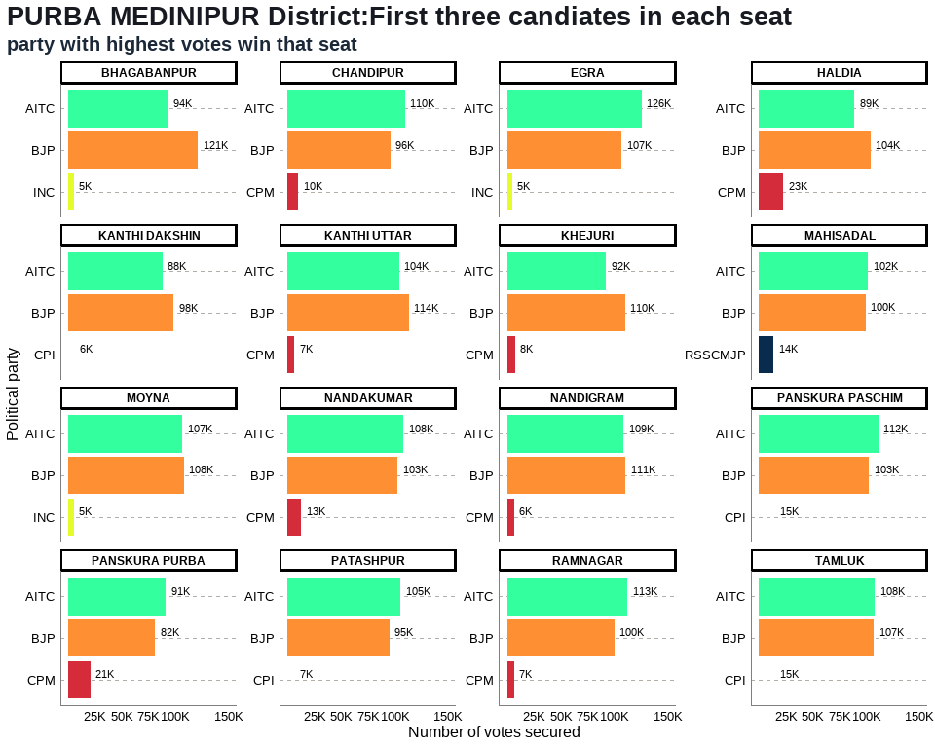

## Table 17: PURBA MEDINIPUR District Election Results: Top 3 Candidates by Votes in Each Constituency

| **Constituency** | **Type** | **Party** | **Candidate** | **Position** | **Votes** | **Margin** |
| --- | --- | --- | --- | --- | --- | --- |
| BHAGABANPUR | GEN | BJP | Rabindranath Maity | 1 | 121,480 | 27,549 |
| BHAGABANPUR | GEN | AITC | Ardhendu Maity | 2 | 93,931 | 88,657 |
| BHAGABANPUR | GEN | INC | Shiu Maiti | 3 | 5,274 | 4,255 |
| CHANDIPUR | GEN | AITC | Soham Chakraborty | 1 | 109,770 | 13,472 |
| CHANDIPUR | GEN | BJP | Pulak Kanti Guria | 2 | 96,298 | 86,461 |
| CHANDIPUR | GEN | CPM | Ashis Kumar Guchhait | 3 | 9,837 | 8,472 |
| EGRA | GEN | AITC | Tarun Kumar Maity | 1 | 125,763 | 18,491 |
| EGRA | GEN | BJP | Arup Dash | 2 | 107,272 | 102,186 |
| EGRA | GEN | INC | Manas Kumar Karmahapatra | 3 | 5,086 | 3,693 |
| HALDIA | SC | BJP | Tapasi Mondal | 1 | 104,126 | 15,008 |
| HALDIA | SC | AITC | Swapan Naskar | 2 | 89,118 | 66,430 |
| HALDIA | SC | CPM | Kar Paik Manika | 3 | 22,688 | 20,766 |
| KANTHI DAKSHIN | GEN | BJP | Arup Kumar Das | 1 | 98,477 | 10,293 |
| KANTHI DAKSHIN | GEN | AITC | Jyotirmoy Kar | 2 | 88,184 | 82,170 |
| KANTHI DAKSHIN | GEN | CPI | Anurup Panda | 3 | 6,014 | 4,878 |
| KANTHI UTTAR | GEN | BJP | Sumita Sinha | 1 | 113,524 | 9,330 |
| KANTHI UTTAR | GEN | AITC | Tarun Kumar Jana | 2 | 104,194 | 97,690 |
| KANTHI UTTAR | GEN | CPM | Sutanu Maity | 3 | 6,504 | 5,012 |
| KHEJURI | SC | BJP | Santanu Pramanik | 1 | 110,407 | 17,965 |
| KHEJURI | SC | AITC | Partha Pratim Das | 2 | 92,442 | 84,630 |
| KHEJURI | SC | CPM | Himangshu Das | 3 | 7,812 | 6,676 |
| MAHISADAL | GEN | AITC | Tilak Kumar Chakraborty | 1 | 101,986 | 2,386 |
| MAHISADAL | GEN | BJP | Biswanath Banerjee | 2 | 99,600 | 85,804 |
| MAHISADAL | GEN | RSSCMJP | Bikram Chatterjee | 3 | 13,796 | 12,031 |
| MOYNA | GEN | BJP | Ashoke Dinda | 1 | 108,109 | 1,260 |
| MOYNA | GEN | AITC | Sangram Kumar Dolai | 2 | 106,849 | 101,741 |
| MOYNA | GEN | INC | Manik Bhaumik | 3 | 5,108 | 3,434 |
| NANDAKUMAR | GEN | AITC | Sukumar De | 1 | 108,181 | 5,406 |
| NANDAKUMAR | GEN | BJP | Adhikary Nilanjan | 2 | 102,775 | 89,993 |
| NANDAKUMAR | GEN | CPM | Karuna Sankar Bhowmik | 3 | 12,782 | 11,309 |
| NANDIGRAM | GEN | BJP | Adhikari Suvendu | 1 | 110,764 | 1,956 |
| NANDIGRAM | GEN | AITC | Mamata Banerjee | 2 | 108,808 | 102,541 |
| NANDIGRAM | GEN | CPM | Minakshi Mukherjee | 3 | 6,267 | 5,177 |
| PANSKURA PASCHIM | GEN | AITC | Phiroja Bibi | 1 | 111,705 | 8,889 |
| PANSKURA PASCHIM | GEN | BJP | Sintu Senapati | 2 | 102,816 | 87,692 |
| PANSKURA PASCHIM | GEN | CPI | Chittaranjan Dasthakur | 3 | 15,124 | 13,787 |
| PANSKURA PURBA | GEN | AITC | Biplab Roy Chowdhury | 1 | 91,213 | 9,660 |
| PANSKURA PURBA | GEN | BJP | Debabrata Pattanayek | 2 | 81,553 | 60,836 |
| PANSKURA PURBA | GEN | CPM | Ibrahim Ali Sk | 3 | 20,717 | 19,259 |
| PATASHPUR | GEN | AITC | Uttam Barik | 1 | 105,299 | 9,994 |
| PATASHPUR | GEN | BJP | Ambujaksha Mahanti | 2 | 95,305 | 88,674 |
| PATASHPUR | GEN | CPI | Saikat Giri | 3 | 6,631 | 5,770 |
| RAMNAGAR | GEN | AITC | Akhil Giri | 1 | 112,622 | 12,517 |
| RAMNAGAR | GEN | BJP | Swadesh Ranjan Nayak | 2 | 100,105 | 93,354 |
| RAMNAGAR | GEN | CPM | Sabyasachi Jana | 3 | 6,751 | 5,518 |
| TAMLUK | GEN | AITC | Saumen Kumar Mahapatra | 1 | 108,243 | 793 |
| TAMLUK | GEN | BJP | Hare Krishna Bera | 2 | 107,450 | 92,732 |
| TAMLUK | GEN | CPI | Goutam Panda | 3 | 14,718 | 11,962 |

## Annex 17: PURULIA DISTRICT

## 17. PURULIA District: Winners per constituency and top 3 candidates

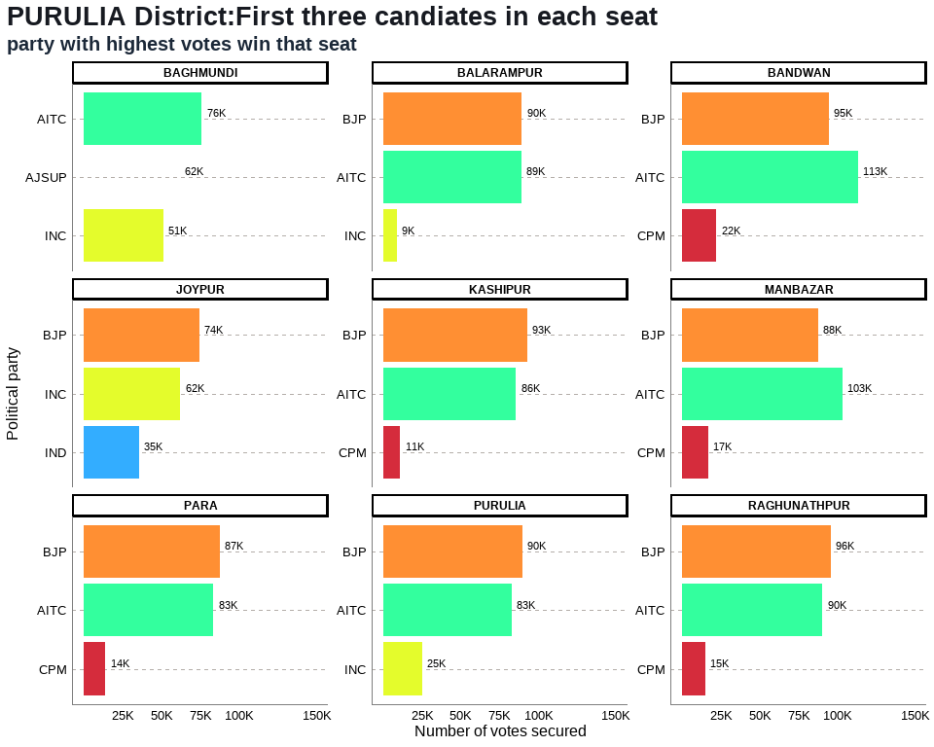

## Table 18: PURULIA District Election Results: Top 3 Candidates by Votes in Each Constituency

| **Constituency** | **Type** | **Party** | **Candidate** | **Position** | **Votes** | **Margin** |
| --- | --- | --- | --- | --- | --- | --- |
| BAGHMUNDI | GEN | AITC | Sushanta Mahato | 1 | 75,905 | 13,969 |
| BAGHMUNDI | GEN | AJSUP | Ashutosh Mahato | 2 | 61,936 | 10,890 |
| BAGHMUNDI | GEN | INC | Nepal Chandra Mahato | 3 | 51,046 | 39,204 |
| BALARAMPUR | GEN | BJP | Baneswar Mahato | 1 | 89,521 | 423 |
| BALARAMPUR | GEN | AITC | Shantiram Mahato | 2 | 89,098 | 80,203 |
| BALARAMPUR | GEN | INC | Uttam Kumar Bandyopadhyay | 3 | 8,895 | 6,454 |
| BANDWAN | ST | AITC | Rajib Lochan Saren | 1 | 113,337 | 18,831 |
| BANDWAN | ST | BJP | Parcy Murmu | 2 | 94,506 | 72,302 |
| BANDWAN | ST | CPM | Besra Susanta Kumar | 3 | 22,204 | 17,137 |
| JOYPUR | GEN | BJP | Nara Hari Mahato | 1 | 74,380 | 12,200 |
| JOYPUR | GEN | INC | Phanibhushan Kumar | 2 | 62,180 | 26,751 |
| JOYPUR | GEN | IND | Dibyajoti Singh Deo | 3 | 35,429 | 16,016 |
| KASHIPUR | GEN | BJP | Kamalakanta Hansda | 1 | 92,938 | 7,387 |
| KASHIPUR | GEN | AITC | Swapan Kumar Beltharia | 2 | 85,551 | 74,624 |
| KASHIPUR | GEN | CPM | Mallika Mahata | 3 | 10,927 | 8,526 |
| MANBAZAR | ST | AITC | Sandhyarani Tudu | 1 | 103,298 | 15,516 |
| MANBAZAR | ST | BJP | Gouri Singh Sardar | 2 | 87,782 | 70,933 |
| MANBAZAR | ST | CPM | Yaminikanta Mandi | 3 | 16,849 | 14,558 |
| PARA | SC | BJP | Nadiar Chand Bouri | 1 | 87,347 | 4,007 |
| PARA | SC | AITC | Umapada Bauri | 2 | 83,340 | 69,659 |
| PARA | SC | CPM | Swapan Kumar Bauri | 3 | 13,681 | 10,024 |
| PURULIA | GEN | BJP | Sudip Kumar Mukherjee | 1 | 89,733 | 7,018 |
| PURULIA | GEN | AITC | Sujoy Banerjee | 2 | 82,715 | 57,719 |
| PURULIA | GEN | INC | Partha Pratim Banerjee | 3 | 24,996 | 22,408 |
| RAGHUNATHPUR | SC | BJP | Vivekananda Bauri | 1 | 95,770 | 5,438 |
| RAGHUNATHPUR | SC | AITC | Bouri Hazari | 2 | 90,332 | 75,594 |
| RAGHUNATHPUR | SC | CPM | Ganesh Bouri | 3 | 14,738 | 10,909 |

## Annex 18: SOUTH 24 PARGANAS DISTRICT

## 18. SOUTH 24 PARGANAS District: Winners per constituency and top 3 candidates

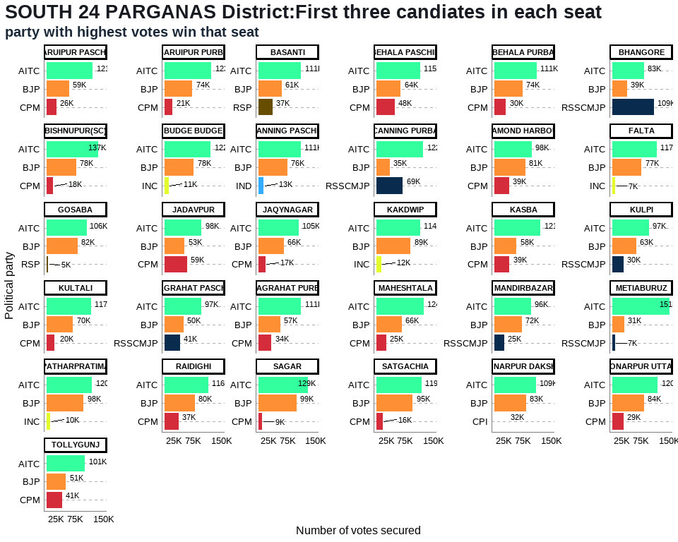

## Table 19: SOUTH 24 PARGANAS District Election Results: Top 3 Candidates by Votes in Each Constituency

| **Constituency** | **Type** | **Party** | **Candidate** | **Position** | **Votes** | **Margin** |
| --- | --- | --- | --- | --- | --- | --- |
| BARUIPUR PASCHIM | GEN | AITC | Biman Banerjee | 1 | 121,006 | 61,910 |
| BARUIPUR PASCHIM | GEN | BJP | Debopam Chattopadhyaya(Babu) | 2 | 59,096 | 33,457 |
| BARUIPUR PASCHIM | GEN | CPM | Md Lahek Ali | 3 | 25,639 | 23,870 |
| BARUIPUR PURBA | SC | AITC | Bivas Sardar (Vobo) | 1 | 123,243 | 49,641 |
| BARUIPUR PURBA | SC | BJP | Chandan Mondal | 2 | 73,602 | 52,135 |
| BARUIPUR PURBA | SC | CPM | Swapan Naskar | 3 | 21,467 | 19,612 |
| BASANTI | SC | AITC | Shyamal Mondal | 1 | 111,453 | 50,642 |
| BASANTI | SC | BJP | Ramesh Majhi | 2 | 60,811 | 24,123 |
| BASANTI | SC | RSP | Subhas Naskar | 3 | 36,688 | 34,781 |
| BEHALA PASCHIM | GEN | AITC | Partha Chatterjee | 1 | 114,778 | 50,884 |
| BEHALA PASCHIM | GEN | BJP | Srabanti Chatterjee | 2 | 63,894 | 16,385 |
| BEHALA PASCHIM | GEN | CPM | Nihar Bhakta | 3 | 47,509 | 45,076 |
| BEHALA PURBA | GEN | AITC | Ratna Chatterjee | 1 | 110,968 | 37,428 |
| BEHALA PURBA | GEN | BJP | Payel Sarkar | 2 | 73,540 | 43,368 |
| BEHALA PURBA | GEN | CPM | Samita Har Chowdhury | 3 | 30,172 | 27,337 |
| BHANGORE | GEN | RSSCMJP | Md. Nawsad Siddique | 1 | 109,237 | 26,151 |
| BHANGORE | GEN | AITC | Karim Rezaul | 2 | 83,086 | 44,360 |
| BHANGORE | GEN | BJP | Soumi Hati | 3 | 38,726 | 33,796 |
| BISHNUPUR(SC) | SC | AITC | Dilip Mondal | 1 | 136,509 | 58,832 |
| BISHNUPUR(SC) | SC | BJP | Agniswar Naskar | 2 | 77,677 | 59,682 |
| BISHNUPUR(SC) | SC | CPM | Jhuma Kayal | 3 | 17,995 | 15,286 |
| BUDGE BUDGE | GEN | AITC | Ashok Kumar Deb | 1 | 122,357 | 44,714 |
| BUDGE BUDGE | GEN | BJP | Dr. Tarun Kumar Adak | 2 | 77,643 | 66,834 |
| BUDGE BUDGE | GEN | INC | Sk Mujibar Rahaman | 3 | 10,809 | 8,074 |
| CANNING PASCHIM | SC | AITC | Paresh Ram Das | 1 | 111,059 | 35,243 |
| CANNING PASCHIM | SC | BJP | Arnab Roy | 2 | 75,816 | 62,426 |
| CANNING PASCHIM | SC | IND | Meghnath Halder | 3 | 13,390 | 1,482 |
| CANNING PURBA | GEN | AITC | Saokat Molla | 1 | 122,301 | 53,007 |
| CANNING PURBA | GEN | RSSCMJP | Gazi Shahabuddin Siraji | 2 | 69,294 | 34,791 |
| CANNING PURBA | GEN | BJP | Kalipada Naskar | 3 | 34,503 | 31,817 |
| DIAMOND HARBOUR | GEN | AITC | Pannalal Halder | 1 | 98,478 | 16,996 |
| DIAMOND HARBOUR | GEN | BJP | Dipak Kumar Halder | 2 | 81,482 | 42,763 |
| DIAMOND HARBOUR | GEN | CPM | Pratik Ur Rahaman | 3 | 38,719 | 37,134 |
| FALTA | GEN | AITC | Sankar Kumar Naskar | 1 | 116,713 | 39,928 |
| FALTA | GEN | BJP | Bidhan Parui | 2 | 76,785 | 69,316 |
| FALTA | GEN | INC | Abdur Razzak Molla | 3 | 7,469 | 5,793 |
| GOSABA | SC | AITC | Jayanta Naskar | 1 | 105,723 | 23,709 |
| GOSABA | SC | BJP | Barun Pramanik (Chitta) | 2 | 82,014 | 77,143 |
| GOSABA | SC | RSP | Anil Chandra Mondal | 3 | 4,871 | 3,600 |
| JADAVPUR | GEN | AITC | Debabrata Majumdar (Malay) | 1 | 98,100 | 38,869 |
| JADAVPUR | GEN | CPM | Dr. Sujan Chakraborty | 2 | 59,231 | 6,092 |
| JADAVPUR | GEN | BJP | Rinku Naskar | 3 | 53,139 | 50,409 |
| JAQYNAGAR | SC | AITC | Biswanath Das | 1 | 104,952 | 38,683 |
| JAQYNAGAR | SC | BJP | Rabin Sardar | 2 | 66,269 | 48,901 |
| JAQYNAGAR | SC | CPM | Apurba Pramanik (Apu) | 3 | 17,368 | 7,945 |
| KAKDWIP | GEN | AITC | Manturam Pakhira | 1 | 114,493 | 25,302 |
| KAKDWIP | GEN | BJP | Dipankar Jana | 2 | 89,191 | 76,957 |
| KAKDWIP | GEN | INC | Indranil Rout | 3 | 12,234 | 10,604 |
| KASBA | GEN | AITC | Ahmed Javed Khan | 1 | 121,372 | 63,622 |
| KASBA | GEN | BJP | Dr. Indranil Khan | 2 | 57,750 | 18,570 |
| KASBA | GEN | CPM | Shatarup Ghosh | 3 | 39,180 | 36,704 |
| KULPI | GEN | AITC | Jogaranjan Halder | 1 | 96,577 | 33,818 |
| KULPI | GEN | BJP | Pranab Kumar Mallik | 2 | 62,759 | 32,798 |
| KULPI | GEN | RSSCMJP | Siraj Uddin Gazi | 3 | 29,961 | 28,276 |
| KULTALI | SC | AITC | Ganesh Chandra Mondal | 1 | 117,238 | 47,177 |
| KULTALI | SC | BJP | Mintu Halder | 2 | 70,061 | 50,051 |
| KULTALI | SC | CPM | Ram Sankar Halder | 3 | 20,010 | 4,704 |
| MAGRAHAT PASCHIM | GEN | AITC | Gias Uddin Molla | 1 | 97,006 | 46,941 |
| MAGRAHAT PASCHIM | GEN | BJP | Dhurjati Saha (Manas) | 2 | 50,065 | 9,380 |
| MAGRAHAT PASCHIM | GEN | RSSCMJP | Maidul Islam Molla | 3 | 40,685 | 38,399 |
| MAGRAHAT PURBA | SC | AITC | Namita Saha | 1 | 110,945 | 54,079 |
| MAGRAHAT PURBA | SC | BJP | Chandan Kumar Naskar | 2 | 56,866 | 23,044 |
| MAGRAHAT PURBA | SC | CPM | Chandan Saha | 3 | 33,822 | 32,342 |
| MAHESHTALA | GEN | AITC | Dulal Chandra Das | 1 | 124,008 | 57,949 |
| MAHESHTALA | GEN | BJP | Umesh Das | 2 | 66,059 | 40,783 |
| MAHESHTALA | GEN | CPM | Pravat Chowdhury | 3 | 25,276 | 23,227 |
| MANDIRBAZAR | SC | AITC | Joydeb Halder | 1 | 95,834 | 23,492 |
| MANDIRBAZAR | SC | BJP | Dilip Kumar Jatua | 2 | 72,342 | 46,945 |
| MANDIRBAZAR | SC | RSSCMJP | Sanchay Kumar Sarkar | 3 | 25,397 | 23,575 |
| METIABURUZ | GEN | AITC | Abdul Khaleque Molla | 1 | 151,066 | 119,604 |
| METIABURUZ | GEN | BJP | Ramjit Prasad | 2 | 31,462 | 24,073 |
| METIABURUZ | GEN | RSSCMJP | Nuruzaman Molla | 3 | 7,389 | 4,381 |
| PATHARPRATIMA | GEN | AITC | Samir Kumar Jana | 1 | 120,181 | 22,134 |
| PATHARPRATIMA | GEN | BJP | Asit Kumar Haldar | 2 | 98,047 | 87,865 |
| PATHARPRATIMA | GEN | INC | Shukdeb Bera | 3 | 10,182 | 8,518 |
| RAIDIGHI | GEN | AITC | Aloke Jaldata | 1 | 115,707 | 35,568 |
| RAIDIGHI | GEN | BJP | Santanu Bapuli | 2 | 80,139 | 43,208 |
| RAIDIGHI | GEN | CPM | Kanti Ganguly | 3 | 36,931 | 34,069 |
| SAGAR | GEN | AITC | Bankim Chandra Hazra | 1 | 129,000 | 29,846 |
| SAGAR | GEN | BJP | Kamila Bikash | 2 | 99,154 | 90,058 |
| SAGAR | GEN | CPM | Sk Muklesur Rahaman | 3 | 9,096 | 8,071 |
| SATGACHIA | GEN | AITC | Mohan Chandra Naskar | 1 | 118,635 | 23,318 |
| SATGACHIA | GEN | BJP | Chandan Pal | 2 | 95,317 | 79,097 |
| SATGACHIA | GEN | CPM | Goutam Pal | 3 | 16,220 | 14,595 |
| SONARPUR DAKSHIN | GEN | AITC | Arundhuti Maitra (Lovely) | 1 | 109,222 | 26,181 |
| SONARPUR DAKSHIN | GEN | BJP | Anjana Basu | 2 | 83,041 | 51,263 |
| SONARPUR DAKSHIN | GEN | CPI | Shuvam Banerjee | 3 | 31,778 | 29,228 |
| SONARPUR UTTAR | GEN | AITC | Firdousi Begum | 1 | 119,957 | 36,090 |
| SONARPUR UTTAR | GEN | BJP | Ranjan Baidya | 2 | 83,867 | 54,467 |
| SONARPUR UTTAR | GEN | CPM | Monalisa Sinha | 3 | 29,400 | 27,286 |
| TOLLYGUNJ | GEN | AITC | Aroop Biswas | 1 | 101,440 | 50,080 |
| TOLLYGUNJ | GEN | BJP | Babul Supriyo | 2 | 51,360 | 10,763 |
| TOLLYGUNJ | GEN | CPM | Debdut Ghosh | 3 | 40,597 | 38,287 |

## Annex 19: UTTAR DINAJPUR DISTRICT

## 19. UTTAR DINAJPUR District: Winners per constituency and top 3 candidates

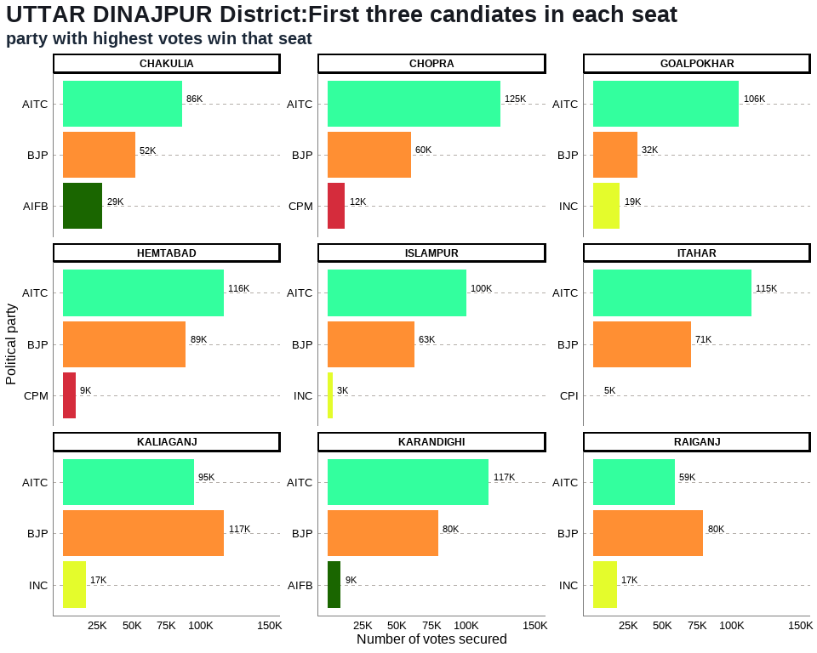

## Table 20: UTTAR DINAJPUR District Election Results: Top 3 Candidates by Votes in Each Constituency

| **Constituency** | **Type** | **Party** | **Candidate** | **Position** | **Votes** | **Margin** |
| --- | --- | --- | --- | --- | --- | --- |
| CHAKULIA | GEN | AITC | Azad Minhajul Arfin | 1 | 86,311 | 33,837 |
| CHAKULIA | GEN | BJP | Sachin Prasad | 2 | 52,474 | 23,770 |
| CHAKULIA | GEN | AIFB | Ali Imran Ramz | 3 | 28,704 | 25,979 |
| CHOPRA | GEN | AITC | Hamidul Rahaman | 1 | 124,923 | 64,905 |
| CHOPRA | GEN | BJP | Md. Shahin Akhter | 2 | 60,018 | 47,739 |
| CHOPRA | GEN | CPM | Anwarul Haque | 3 | 12,279 | 9,113 |
| GOALPOKHAR | GEN | AITC | Md. Ghulam Rabbani | 1 | 105,649 | 73,514 |
| GOALPOKHAR | GEN | BJP | Md. Ghulam Sarwar | 2 | 32,135 | 12,744 |
| GOALPOKHAR | GEN | INC | Masood Md. Naseem Ahsen | 3 | 19,391 | 17,375 |
| HEMTABAD | SC | AITC | Satyajit Barman | 1 | 116,425 | 27,215 |
| HEMTABAD | SC | BJP | Chandima Roy | 2 | 89,210 | 79,757 |
| HEMTABAD | SC | CPM | Bhupen Barman | 3 | 9,453 | 7,293 |
| ISLAMPUR | GEN | AITC | Abdul Karim Chowdhary | 1 | 100,131 | 37,440 |
| ISLAMPUR | GEN | BJP | Saumyaroop Mandal | 2 | 62,691 | 59,230 |
| ISLAMPUR | GEN | INC | Sadiqul Islam | 3 | 3,461 | 1,485 |
| ITAHAR | GEN | AITC | Mosaraf Hussen | 1 | 114,645 | 43,975 |
| ITAHAR | GEN | BJP | Amit Kumar Kundu | 2 | 70,670 | 65,762 |
| ITAHAR | GEN | CPI | Srikumar Mukherjee | 3 | 4,908 | 3,668 |
| KALIAGANJ | SC | BJP | Soumen Roy | 1 | 116,768 | 21,820 |
| KALIAGANJ | SC | AITC | Tapan Deb Singha | 2 | 94,948 | 78,178 |
| KALIAGANJ | SC | INC | Pravash Sarkar | 3 | 16,770 | 12,766 |
| KARANDIGHI | GEN | AITC | Goutam Paul | 1 | 116,594 | 36,626 |
| KARANDIGHI | GEN | BJP | Subhas Chandra Sinha S/O: Haranarayan Sinha | 2 | 79,968 | 70,822 |
| KARANDIGHI | GEN | AIFB | Md. Hafizul Iqbal | 3 | 9,146 | 6,697 |
| RAIGANJ | GEN | BJP | Krishna Kalyani | 1 | 79,775 | 20,748 |
| RAIGANJ | GEN | AITC | Agarwal Kanaia Lal | 2 | 59,027 | 41,829 |
| RAIGANJ | GEN | INC | Mohit Sengupta | 3 | 17,198 | 14,730 |